Class – 9 Concise Physics Solutions
Chapter- Laws of Motion
Exercise 3(A)
1.a. The forces which act on bodies when they are in physical contact are called contact forces.
Example: frictional force and force exerted on two bodies during collision.
b. The forces experienced by bodies even without being physically touched are called non-contact forces.
Example: Gravitational force and Electrostatic force.

2.Contact force: (a) frictional force (b) normal reaction force (c) force of tension in a string
Non-contact force: (d) gravitational force (e) electric force (f) magnetic force

3.a. Force exerted on two bodies during collision.
b. Magnetic force between magnetic poles.

4.A.
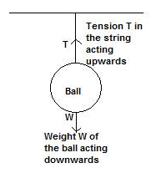

B.

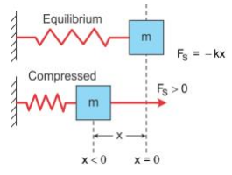

C.
The forces acting on the block are its weight in the downward direction and the normal reaction force due to the table on the upward direction.

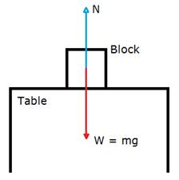

5.The magnitude of non-contact force on two bodies depends on the distance of separation between them.
The force decreases as the distance of separation increases.
The force is inversely proportional to the square of the distance of separation.

6.The magnitude of gravitational force between two masses will become four times as gravitational force varies inversely as the square of distance of separation.

7.A force when applied on a non-rigid body changes the inter-spacing between its constituent particles and therefore causes a change in its dimensions and can also produce motion in it.

On the other hand, a force when applied on a rigid body, does not change the inter-spacing between its constituent particles and therefore it does not change the dimensions of the body but causes motion in it

8.

- A fielder on the ground stops a moving ball by applying a force with his hands.
- The pull exerted by horse makes a cart moves.
- In a cycle pump, when the piston is lowered, the air is compressed to occupy a less volume.
- On pressing a piece of rubber, its shape changes.

MULTIPLE CHOISE QUESTION :-

1. Frictional force is a contact force.

2.Force due to gravity is a non-contact force.

EXERCISE 3(B)

- Force causes motion in a body.
- Force is not needed to keep a moving body in motion.
- The force of friction between the table and the ball opposes the motion of the ball.
- In absence of any external force, its speed shall remain unchanged.
- Galileo's law of inertia states that a body continues to be in its state of rest or of uniform motion unless an external force is applied on it.
- According to Newton's first law of motion, if a body is in a state of rest, it will remain in the state of rest, and if the body is in the state of motion, it will remain moving in the same direction with the same speed unless an external force is applied on it.
- Statement of Newton's first law: If a body is in a state of rest, it will remain in the state of rest, and if the body is in the state of motion, it will remain moving in the same direction with the same speed unless an external force is applied on it.
Explanation: Newton's first law can be explained in the following two parts:
(i) Definition of inertia: The 1st part of Newton's first law of motion gives the definition of inertia, according to which an object cannot change its state by itself.
Example: A book lying on a table will remain in its position unless it is displaced.
(ii) Definition of force: The 2nd part of Newton's first law defines force, according to which force is that external cause which can move a stationary object or which can stop a moving object.
Example: A book lying on a table is displaced from its place when it is pushed.

- The property of an object by virtue of which it neither changes its state nor tends to change the state is called inertia.
- Force is that external cause which can move a stationary object or which can stop a moving object.
- Inertia of a body depends on its mass. Inertia is directly proportional to mass, i.e. greater the mass of a body, greater is its inertia.
- Examples to show that greater the mass, greater is the inertia of the body are as shown below:
(i) If you want to start a car by pushing it, you find that it takes a very large force to overcome its inertia. On the other hand, only a small force is needed to start a child's express wagon. The difference between the car and express wagon is the difference in mass. The car has a large mass, whereas the wagon has a small one.
(ii) A cricket ball is more massive than a tennis ball. The cricket ball acquires a much smaller velocity than a tennis ball when the two balls are pushed with equal force for the same time.
- It is difficult, i.e. a larger force is required to set a loaded trolley (which has more mass) in motion than an unloaded trolley (which has less mass).
- Two kinds of inertia are as listed below:
(i) Inertia of rest.
(ii) Inertia of motion.
- Examples of inertia of rest: A coin placed on top of a card remains in place when the card is slightly and quickly jerked horizontally.
Example of inertia of motion: A ball thrown vertically upwards by a person in a moving train comes back to his hand.
- No, the body will not move because the net force acting on it is zero. Hence, it will remain stationary due to inertia of rest.
- The motion remains unaffected because the net force acting on it is zero.
- The net force on the airplane is zero or the upward force is equal to the downward force.
- If a person jumps out of a moving train and tries to stop immediately, he falls due to inertia of motion. This is because his body tends to move forward with the velocity of the train while his feet are stationary.
- The reason is that when the card is flicked, a momentary force acts on the card, so it moves away. However, the coin kept on it does not share the motion at once and it remains stationary at its place due to the inertia of rest. The coin then falls down into the tumbler due to the pull of gravity.
- The reason is that when the ball is thrown, the ball is in motion along with the person and train. Due to the inertia of motion, during the time the ball remains in air, the person and ball move ahead by the same distance. This makes the ball fall back into the thrower's hand.
- (a) When a train suddenly starts, the passengers tend to fall backwards. This is because the lower part of the body, which is in contact with the train, begins to move while the upper part of the body tends to maintain its position of rest. As a result, the upper part tends to fall backwards.
(b) The frame of the sliding door being in contact with the floor of the train also comes in motion on start of the train, but the sliding door remains in its position due to inertia. Thus, the frame moves ahead with the train, while the door slides opposite to the direction of motion of the train. Thus, the door may shut or open accordingly.
(c) When the branches of the tree are shaken, they come in motion, while the fruits due to inertia remain in a state of rest. Thus, the larger and weakly attached fruits get detached from the branches and fall down due to the pull of gravity.
(d) When people alight from a moving bus, they continue to run alongside the bus to avoid falling. If they were to stop at once, the feet would come to rest suddenly but the upper part of the body would still be in motion and they would tend to fall forward.
(e) The part of the carpet where the stick strikes comes in motion at once, while the dust particles settled on it remain in the state of rest due to inertia of rest. Thus, a part of the carpet moves ahead with the stick leaving behind the dust particles that fall down due to gravity.
(f) When running, the athlete brings his body in the state of motion. When the body is in motion, it becomes easier to take a long jump.
MULTIPLE CHOISE QUESTION :-
- A truck
- Less force is required for the tennis ball than for the cricket ball.
- Change the state of motion or state of rest of the body.

EXERCISE 3(C)
- Force needed to stop a moving body in a given time depends on its mass and velocity.
- Linear momentum of a body is the product of its mass and velocity.
Its SI unit is kgms⁻¹.
- (i) When vc,
p = (mv) = mv

(ii) When v c,
p = (mv)

(iii) When vc but m does not remain constant.
p = (mv)

- Let a force 'F' be applied on a body of mass m for a time 't' due to which its velocity changes from u to v. Then,
Initial momentum of body = mu
Final momentum of body = mv
Change in momentum of the body in 't' seconds = mv mu = m (vu)
Rate of change of momentum = Change in momentum/time
= [m (vu)]/t
However, acceleration a = Change in velocity/time = (vu)/t
Therefore, rate of change of momentum = ma = mass × acceleration
This relation holds true when the mass of the body remains constant.
- (i) Mass is the measure of inertia.
Let 'm' be the mass of the two bodies.
Inertia of body A:Inertia of body B :: m:m
Or, Inertia of body A:Inertia of body B :: 1:1

(ii) Momentum of body A = m (v)
Momentum of body B = m (2v) = 2mv
Momentum of body A:Momentum of body B :: mv:2mv
Or, Momentum of body A:Momentum of body B :: 1:2.
- (i) Inertia of body A:Inertia of body B :: m:2m
Or, Inertia of body A:Inertia of body B :: 1:2.

(ii) Momentum of body A = m ( 2v) = 2mv
Momentum of body B = (2m) v = 2mv
Momentum of body A:Momentum of body B :: 2 mv:2mv
Or, Momentum of body A:Momentum of body B :: 1:1.

(iii) According to Newton's 2nd law of motion, rate of change of momentum is directly proportional to the force applied on it. Therefore,
Force needed to stop A:Force needed to stop B :: 1:1.
- According to Newton's second law of motion, the rate of change of momentum is directly proportional to the force applied on it and the change of momentum takes place in the direction in which the force is applied.

It gives the quantitative value of force, i.e. it relates the force to the measurable quantities such as acceleration and mass.
- Newton's first law of motion gives the qualitative definition of force. It explains the force as the cause of acceleration only qualitatively but Newton's second law of motion gives the quantitative value of force. It states force as the product of mass and acceleration. Thus, it relates force to the measurable quantities such as acceleration and mass.
- Mathematical expression of Newton's second law of motion is as shown below:

Force = Mass × Acceleration

Above relation holds for the following conditions:
(i) When the velocity of the body is much smaller than the velocity of light.
(ii) When the mass remains constant.
- According to Newton's second law of motion, the rate of change of momentum is directly proportional to the force applied on it, and the change of momentum takes place in the direction in which the force is applied.

The relation F=ma holds for the following conditions:
(i) When the velocity of the body is much smaller than the velocity of light.
(ii) When the mass remains constant.
- From Newton's second law of motion, F = ma.
If F = 0, then a = 0.
This means that if no force is applied on the body, its acceleration will be zero. If the body is at rest, then it will remain in the state of rest and if it is moving, then it will remain moving in the same direction with the same speed. Thus, a body not acted upon by an external force, does not change its state of rest or motion. This is the statement of Newton's first law of motion.

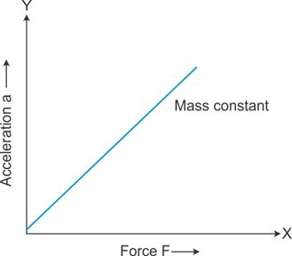
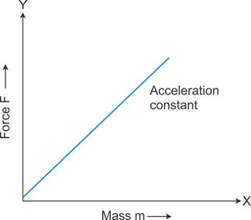

If a given force is applied on bodies of different masses, then the acceleration produced in them is inversely proportional to their masses.
A graph plotted for acceleration (a) against mass (m) is a hyperbola.
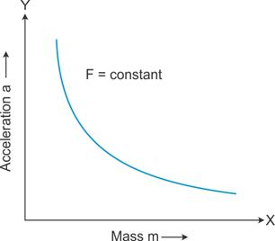

- The S.I. unit of force is newton.
One newton is the force which acts on a body of mass 1kg and produces an acceleration of 1 m/s², i.e. 1 N = 1 kg × 1 m/s².

- The C.G.S. unit of force is dyne.
One dyne is the force which acts on a body of mass 1 gramme and produces an acceleration of 1 cms⁻², i.e. 1 dyne = 1 g × 1 cms⁻².
- The S.I. unit of force is newton and the C.G.S. unit of force is dyne.
1 N = 10⁵ dyne.

- When a glass vessel falls from a height on a hard floor, it comes to rest almost instantaneously, i.e. in a very short time, so the floor exerts a large force on the vessel and it breaks. However, if it falls on a carpet, then the time duration, in which the vessel comes to rest, increases, so the carpet exerts less force on the vessel and it does not break.

- (a) We pull our hands back while catching a fast moving cricket ball, because by doing so, we increase the time of catch, i.e. increase the time to bring about a given change in momentum, and hence, the rate of change of momentum decreases. Thus, a small force is exerted on our hands by the ball.
(b) When an athlete lands from a height on a hard floor, his feet comes to rest instantaneously, so a very large force is exerted by the floor on his feet, but if he lands on sand, his feet push the sand for some distance; therefore, the time duration in which his feet comes to rest increases. As a result, the force exerted on his feet decreases and he is saved from getting hurt.
MCQ.
- Mv
- N s
- 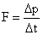
- Mass of the body

EXERCISE 3(D)

- Newton's third law explains how a force acts on an object.
- According to Newton's third law of motion, to every action there is always an equal and opposite reaction. The action and reaction act simultaneously on two different bodies.
- Law of action and reaction: In an interaction of two bodies A and B, the magnitude of action, i.e. the force F_{AB} applied by the body B on the body A, is equal in magnitude to the reaction, i.e., the force F_{BA} applied by the body A on the body B, but they are in directions opposite to each other.
Examples:
(i) When a book is placed on a table, it does not move downwards. It implies that the resultant force on the book is zero, which is possible only if the table exerts an upward force of reaction on the book, equal to the weight of the book.
(ii) While moving on the ground, we exert a force by our feet to push the ground backwards; the ground exerts a force of the same magnitude on our feet forward, which makes it easier for us to move.

Explanation: In the above stated example, there are two objects and two forces. In the first example, the weight of the book acts downwards (action) and the force of the table acts upwards (reaction).
In the second example, our feet exerts a force on the ground (action) and the ground exerts an equal and opposite force (reaction) on our feet.
- (a) Action: Force exerted on the bullet.
Reaction: Recoil experienced by the gun.
(b) Action: The force exerted by the hammer on the nail.
Reaction: The force applied by the nail on the hammer.
(c) Action: Weight of the book acting downwards.
Reaction: Force acted by the table upwards.
(d) Action: Force exerted by the rocket on the gases backwards.
Reaction: Force exerted by outgoing gases on the rocket in forward direction.
(e) Action: Force exerted by the feet on the ground in backward direction.
Reaction: Force exerted by the ground on feet in forward direction.
(f) Action: Force exerted by a moving train on a stationary train.
Reaction: Force exerted by a stationary train on a moving train.
- When a rocket moves in space, it pushes gases outside, i.e. the rocket applies force on the gases in the backward direction. As a reaction, the gases put equal amount of force on the rocket in the opposite direction and the rocket moves in the forward direction.
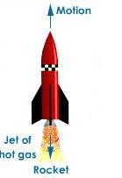
- When a man fires a bullet from a gun, a force F is exerted on the bullet (action), and the gun experiences an equal and opposite recoil (reaction) and hence gets recoiled.
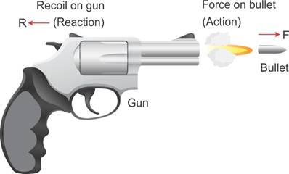
- When a man exerts a force (action) on the boat by stepping into it, its force of reaction makes him step out of the boat, and the boat tends to leave the shore due to the force exerted by the man (i.e. action).
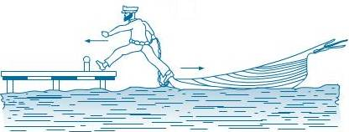
- Couple two spring balances A and B as shown in the figure. When we pull the balance B, both the balances show the same reading indicating that both the action and reaction forces are equal and opposite. In this case, the pull of either of the two spring balances can be regarded as action and that of the other balance as the reaction.

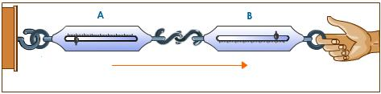
- To move a boat, the boatman pushes (action) the water backwards with his oar. In this response, the water exerts an equal and opposite force (reaction) in the forward direction on the boat due to which the boat moves ahead.
- A person pushing a wall hard (action) by his palm, experiences a force (reaction) exerted by the wall on his palm in the opposite direction; thus, he is liable to fall backwards.
- Yes, action and reaction act simultaneously.
- Yes, action and reaction are equal in magnitude.
- When a falling ball strikes the ground, it exerts a force on the ground. The ground exerts a force back at the ball in the opposite direction. This is the reason the ball rises upwards.
- The given statement is wrong.
Reason: According to Newton's third law of motion, the action and reaction act simultaneously on different bodies. Hence they do not cancel each other.

MCQ.
- Explains the way the force acts on a body.
- Different bodies in opposite directions

EXERCISE 3(E)

- Newton's law of gravitation: Every particle in the universe attracts every other particle with a force which is directly proportional to the product of their masses and inversely proportional to the square of the distance between them, and the direction of the force is along the line joining the masses.
- Gravitational force is always attractive.

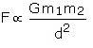Here G is a constant of proportionality called the universal gravitational constant.
- The gravitational force of attraction between two masses is inversely proportional to the square of distance between them.

If the distance between the masses becomes half, the force reduces to one-fourth.

- The gravitational constant is defined as the force of attraction between two bodies of unit mass separated by a unit distance.
- The value of G in the S.I. system is 6.67 x 10⁻¹¹Nm²kg⁻².
- The gravitational force of attraction is significant to explain the motion of heavenly bodies, e.g. motion of planets around the Sun, motion of the Moon around the Earth etc.
- The force with which the Earth attracts a body towards its centre is called the force due to gravity.
- The force due to gravity on a body of mass m kept on the surface of Earth (`mass=M and radius=R) is equal to the force of attraction between the Earth and that body.
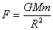

- The rate at which the velocity of a freely falling body increases is called acceleration due to gravity. Its S.I. unit is m/s².

- The average value of 'g' on the Earth's surface is 9.8 m/s².
- Let g be the acceleration due to gravity on the Earth's surface (mass = M and radius = R).
Then,
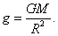
- Acceleration due to gravity (g) is directly proportional to universal gravitational constant (G).
- Initial velocity, u = 0.
Time taken = t.
Acceleration due to gravity = g.
Let 'h' be the height fallen.

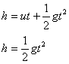
- If a body is thrown vertically up with an initial velocity u to a height h, then there will be retardation (a = g).
At the highest point, the final velocity v = 0.
Thus, from the third equation,
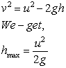
- Mass: The mass of a body is the quantity of matter it contains.
Weight: The weight of a body is the force with which the Earth attracts it.

- Mass is a scalar quantity, but weight is a vector quantity. Mass is the measure of the quantity of matter contained in a body, but weight is the measure of force with which the Earth attracts the body. Mass of a body is always constant but weight varies from place to place.
- The S.I. unit of mass is kg and that of weight is newton.
- W = mg
At the centre of Earth, g = 0.
Therefore, W = 0.
- Mass of a body is always constant.
- 1 kgf = 9.8 N.
One kilogramme force is the force due to gravity on a mass of 1 kilogramme.

MCQ.
- Always attractive
- 6.7 x 10⁻¹¹ N m² kg⁻²
- 6.7 x 10⁻¹¹ N

METHOD: Let't' be the time in which the body reaches its maximum height.
Initial velocity = u.
Final velocity (at the highest point) = 0.
Acceleration due to gravity = g (negative sign indicates the body is moving against gravity).
Using the first equation of motion,
v = u + gt.
We get,
0 = u gt
Or t = u/g
Now total time for which the ball remains in air = Time of ascent + Time of descent
Because time of ascent = Time of descent,
Total time taken = u/g + u/g = 2u/g

5. 19.6 m s⁻¹
METHOD: Given, u = 0
g = 9.8 m/s²
Time t = 2s
Let 'v' be the velocity of object on reaching the ground.
Using the first equation of motion,
v = u + gt
We get,
v = 0 + (9.8) (2)
Or, v = 19.6 m/s.

