Class 10 –ICSE
Chapter-2 Chemical Bonding
Exercise 1
- (a) Electrovalent compounds in the solid state do not conduct electricity because movement of ions in the solid state is not possible due to their rigid structure. But these compounds conduct electricity in the molten state. This is possible in the molten state since the electrostatic forces of attraction between the oppositely charged ions become weak. Thus, the ions move freely and conduct electricity.
(b) The atoms of covalent compounds are bound tightly to each other in stable molecules, but the molecules are generally not very strongly attracted to other molecules in the compound. On the other hand, the atoms (ions) in electrovalent compounds show strong attractions to other ions in their vicinity. This generally leads to low melting points for covalent solids, and high melting points for electrovalent solids.
(c) Electrovalent compounds dissolve in polar solvents like water because the forces of attraction between positive and negative charges become weak in water. But since covalent compound are made up of molecules, they do not ionize in water and hence do not dissolve in water.
(d) Since it takes a lot of energy to break the positive and negative charges apart from each other, the ionic compounds are so hard. But on applying stress, Ions of the same charge are brought side-by-side and so the opposite ions repel each other and crystal breaks into pieces.
(e) Since polar covalent compounds are made up of charged particles, they conduct electricity in aqueous solution.

(2004)
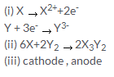
(2005)
(a) (i) C (ii) C (iii) D
(b) (i)reduced (ii) negative
(c) (i) H₃O⁺ ions

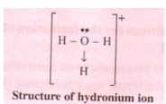

(ii) Like dissolves like. Since carbon tetrachloride is non-polar and water is polar compound, carbon tetrachloride does not dissolve in water.
(iii) Solid
(iv) No as ionic bonds can only be made by transfer of electrons from a metal to non metal.

(2006)
(a) (i) B (ii) A
(b) (i) Reduction
(ii) Oxidation
(iii) Reduction

(2007)
(i) Ions
(ii) Electrons are shared between the atoms of two or more elements
(iii) Two
(iv) Magnesium is oxidized and chlorine is reduced

(2008)
(a)
(i) D
(b)
(i) Covalent bond
(ii) Coordinate bond.

- The solid is ionic in nature as the oppositely charged ions are being held tightly by strong intermolecular force of attraction and that's the reason for its high melting point and solubility in water.
- (a) Atomic number 15
(b) Atomic number 8
(c) Atomic number 19
(d) Atomic number 14

- (a) Y
(b) Z
(c) X

Electrovalent Compounds | Covalent compounds
They are made up of ions; Mg²⁺ and Cl⁻ | They are made up of molecules; 1carbon and 4 chlorine atoms form a molecule of CCl₄.
They are generally crystalline solids; MgCl₂ is a solid . | They are generally gases or liquids under ordinary conditions; CCl₄ is a liquid.
They have high m.p. and b.p. | Their m.p. and b.p. are low.
They are easily soluble in water but insoluble in organic solvents, such as benzene, chloroform, etc. | They are insoluble in water but are usually soluble in organic solvents, such as benzene, chloroform, etc.

- Potassium chloride conducts electricity in water because the forces of attraction between positive and negative charged ions become weak in water and hence the ions become mobile.
On the other hand, the HCl bond is a polar covalent compound, which means that there is a partial positive charge on H and a partial negative charge on Cl.. Hence it also ionizes in water and forms ions and conducts electricity.

- (a) HCl and H₂O
(b) H⁺ and Cl⁻ ions
And
H⁺ and O²⁻ ions

- Since M combines with oxygen to form MO which means that M has a valency of +2. Hence, the formula of the compounds with chlorine and sulphur are: MCl₂ and MS.

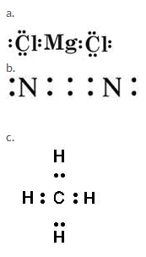
- a. Water - Covalent bond
b. Calcium oxide - Ionic bond
c. Hydroxyl ion - Polar covalent bond
d. Methane - Covalent bond
e. Ammonium ion - Co-ordinate covalent bond
f. Ammonium chloride - Covalent, coordinate and ionic bonds

- The bond formed between two atoms by sharing a pair of electrons, provided entirely by one of the combining atoms but shared by both is called a coordinate bond. It is represented by an arrow starting from the donor atoms and ending in the acceptor atom.
Conditions:
1. One of the two atoms must have at least one lone pair of electrons.
2. Another atom should be short of at least a lone pair of electrons.
The two lone pair of electrons in the oxygen atom of water is used to form coordinate bond with the hydrogen ion which is short of an electron resulting in the formation of the hydronium ion.
Over here the hydrogen ion accepts one lone pair of electrons of the oxygen atom of water molecule leading to the formation of a coordinate covalent bond.

- (a) A pair of electrons which is not shared by any other atom is called lone pair of electrons.
The electrons of valence shell shared by two atoms to form a covalent bond are called shared pair of electrons.
(b)
(i) Calcium and oxygen make up Calcium oxide. Calcium needs to lose 2 electrons while oxygen needs to gain 2 electrons to complete octet structure. ii) Two atoms of hydrogen and an atom of oxygen make up water molecule. .Hydrogen atoms need to gain one electron to complete its duplet while oxygen needs to gain 2 electrons to complete octet structure.
(ii) In carbon tetrachloride, there is one carbon and 4 chlorine atoms. Each of the four chlorine atoms needs to gain one electron to complete its octet while carbon needs to gain 4 electrons to complete octet state.

- (a) Unequal, polar
(b) Middle, equally
(c) Electrovalent, electrostatic

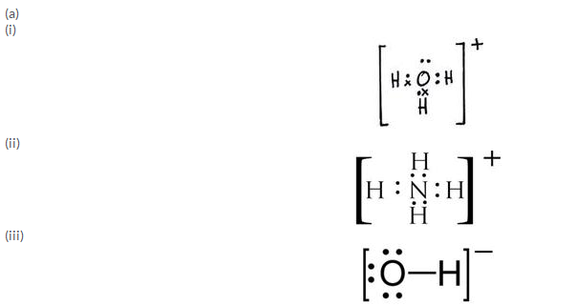

(b)
(i) Ammoniumion and hydronium ion
(ii) Phosphoruspentachloride and diamond
(iii) Hydrogen chloride and water vapour
(iv) Oxygen gas and nitrogen gas
(v) Toluene and Gasoline

- Mg

 | Sodium | Phosphorus | Carbon
Formula of chloride | NaCl | PCl₅ | CCl₄
Nature of bonding | Ionic | Covalent | Covalent
Physical state of chloride | Solid | Solid | Liquid

Intext 1.
- Atoms lose, gain or share electrons to attain noble gas configuration.

- (a) A chemical bond may be defined as the force of attraction between any two atoms, in a molecule, to maintain stability.
(b) The chemical bond formed between two atoms by transfer of one or more electrons from the atom of a metallic electropositive element to an atom of a non-metallic electronegative element.
(c) The chemical bond formed due to mutual sharing of electrons between the given pairs of atoms of non-metallic elements.
- Conditions for formation of Ionic bond are:
(i) The atom which changes into cation should possess 1, 2 or 3 valency electrons. The other atom which changes into anion should possess 5, 6 or 7 electrons in the valence shell.
(ii) A high difference of electronegativity of the two atoms is necessary for the formation of an Ionic bond.
(iii) There must be an overall decrease in energy i.e., energy must be released.
For this an atom should have low value of Ionisation potential and the other atom should have high value of electron affinity.
(iv) Higher the lattice energy, greater will be the case of forming an ionic compound.

- It will form a cation: M³⁺
M₂(SO₄)₃
M(NO₃)₃
M₃(PO₄)₃
M₂(CO₃)₃
M(OH)₃
- Atoms combine with other atoms to attain stable octet or noble gas configuration.
- Ionic compounds are generally formed between metals and non-metals as metals always lose electrons to form cations while non-metals gain electrons forming anions to complete their octet. These oppositely charged ions are held together by electrostatic force of attraction and hence results in an ionic compound.

- X and Y form an ionic bond in XY₂.
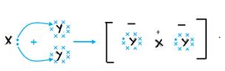
- (a) X has 7 electrons in its outermost shell and Y has only one electron in its outermost shell so Y loses its one electron and X gains that electron to form an ionic bond.
(b) The formula of the compound would be XY.

- Orbit structure and electron dot diagram of NaCl:

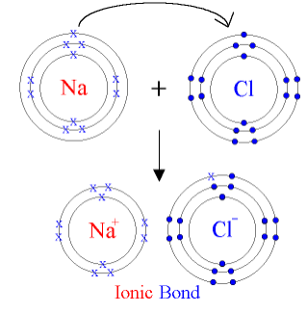
Orbit structure and electron dot diagram of MgCl₂:
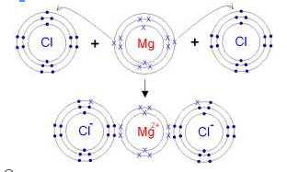
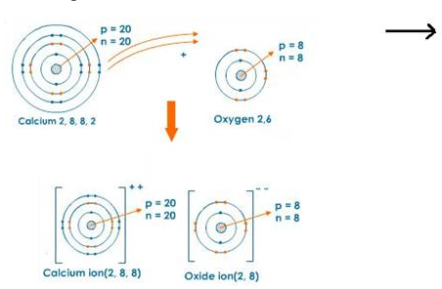

- (a) Sodium atom and sodium ion
(i) Sodium atom has one electron in M shell while sodium ion has 8 electrons in L shell.
(ii) Sodium atom is neutral while sodium ion is positively charged.
(iii) Sodium atom is highly reactive while its ion is inert.
iv) Sodium atom is poisonous while sodium ion is non-poisonous.
(b)Chlorine atom and chlorine ion
(i) Chlorine atom has 7 electrons in its M shell while Chloride ion has 8 electrons in the same shell.
(ii) Chlorine atom is neutral while chloride ion is negatively charged.
(iii) Chlorine atom is highly reactive while its ion is inert.
iv) Chlorine gas is poisonous while chloride ion is non-poisonous.
- Fluoride ion is negatively charged while neon atom is neutral.

Intext 2.
- (i) Both atoms should have four or more electrons in their outermost shells, i.e., non-metals.
(ii) Both the atoms should have high electronegativity.
(iii) Both the atoms should have high electron affinity and high ionisation potential.
(iv) Electronegativity difference between the two atoms should be zero or negligible.
(v) The approach of the atoms towards one another should be accompanied by decrease of energy.
- (a) A is a non-metal; B is a metal while C is a chemically inert element.
(b) BA

- (a) (i) E (ii) B
(b) C₂D
(c) A and C are metals while B, D and E are non -metals.
- (a) Ionic compounds are formed as a result of transfer of one or more electrons from the atom of a metallic electropositive element to an atom of a non-metallic electronegative element.
A polar covalent compound is the one in which there is an unequal distribution of electrons between the two atoms.
(b) Ionic compounds, made up of ions, are generally crystalline solids with high melting and boiling points.
They are soluble in water and good conductors of electricity in aqueous solution and molten state.
Covalent compounds, made up of molecules, can exist as soft solids or liquids or gases with low melting and boiling points. They are generally insoluble in water and poor conductors of electricity.
(c) Polar covalent compounds are formed between 2 non-metal atoms that have different electronegativities and therefore have unequal sharing of the bonded electron pair. Non-polar compounds are formed when two identical non-metals equally share electrons between them.

- (a) X⁺
(b) X will be a strong reducing agent as it will have the tendency to donate its valence electron.

- Covalent compounds are said to be polar when shared pair of electrons are unequally distributed between the two atoms. For example in HCl, the high electronegativity of the chlorine atom attracts the shared electron pair towards itself. As a result, it develops a slight negative charge and hydrogen atom develops a slight positive charge. Hence, a polar covalent bond is formed.
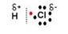
- During the formation of a non-polar covalent bond between two similar atoms or dissimilar atoms, the atoms involved in sharing share the electrons equally. The molecule of methane has four carbon-hydrogen single covalent bonds. It is a non-polar covalent compound as the electrons are shared by the carbon and hydrogen atoms equally and hence the shared pair lies between the atoms at an equal distance from both carbon and hydrogen atom.

- (a) Properties of Ionic Compounds:
1. Ionic compounds usually exist in the form of crystalline solids.
2. Ionic compounds have hisgh melting and boiling points.
3. Ionic compounds are generally soluble in water but insoluble in organic solvents.
4. They are good conductors of electricity in the fused or in aqueous solution state.
(b) Properties of Covalent Compounds:
1.The covalent compounds exist as gases or liquids or soft solids.
2. The melting and boiling points of covalent compounds are generally low.
3. Covalent compounds are insoluble in water but dissolve in organic solvents.
4. They are non-conductors of electricity in solid, molten or aqueous state.

- (a) A reaction in which oxidation and reduction occur simultaneously is called an oxidation-reduction, or simply, a redox reaction.
Redox reactions involve the transfer of electrons between two chemical species.
The reaction in which electron is gained is called a reduction reaction and the reaction in which electron is lost is called oxidation reaction.
The compound that loses an electron is said to be oxidized, the one that gains an electron is said to be reduced.
(b)
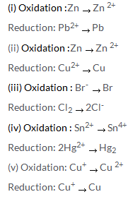
(c)
(i) Potassium undergoes oxidation as it loses an electron and forms a cation.
(ii) Chlorine undergoes reduction as it gains an electron and forms chloride anion.
(iii) Potassium acts a reducing agent and gets oxidised.
(iv) Chlorine acts an oxidizing agent and gets reduced.

- Dipole molecule is a molecule that has both, slight positive and slight negative charge.
For example, in HCl hydrogen has a slight positive charge and chlorine has a slight negative charge. The dipole moment of HCl molecule is 1.03 D and may be represented as:

