Class 9 –ICSE
Chapter-2 Study of Gas Laws.
Exercise 2(A)
- The state of matter in which inter-particle attraction is weak and inter-particle space is so large that the particles become completely free to move randomly in the entire available space, is known as gas.
- The main assumption of kinetic molecular theory of gases are as follows:
(1) All gases are made up of a large number of extremely small particles called molecules. (2) There are large vacant spaces between the molecules of a gas so that actual volume of the molecules of a gas is negligible as compared to the total volume occupied by the gas.
(3) The molecules of a gas are always in a state of constant random motion in straight lines in all possible direction.
(4) There are negligible attractive forces between the molecules of a gas. (5) There is no effect of gravity on the motion of the molecules of a gas.
(6) The average kinetic energy of the molecules of a gas is directly proportional to that of the Kelvin temperature of the gas.
(7) The molecules are perfectly elastic so that there is no net loss of energy during molecular collisions.
(8) The pressure of a gas is due to the bombardment of the molecules of a gas against the walls of a container.

- In a laboratory, when hydrogen sulphide gas is prepared, it can be smelt even at 50 meters away. This is due to the phenomenon called Diffusion.
Diffusion is a process of intermixing of two substances kept in contact.
The inter-particle or inter molecular spaces in a gas are very large. When hydrogen sulphide gas is produced, its particle collides with air particles. Due to the collisions of particles, they start moving in all possible directions. As a result of which the two gases mix with each other forming a homogeneous mixture of a gas. Thus, the released gas can be smelt to a long distance.

- Pressure and volume relationship of gases- Experiment: Take a 10 mL syringe fitted with a piston. Raise the latter to the 10 mL mark and wrap an adhesive tape over its nozzle. Fit the wrapped nozzle tightly into a hole, bored half way through a rubber stopper.
Observation: On placing some weight on the piston (to put pressure), the piston moves downward and reduces the volume of air. Gradually, put more weight. The piston moves further downward and the volume of the air is further reduced.
Now remove the weights one by one. You will notice that, on decreasing the pressure, the piston moves upward as such the volume of the air increases.
Conclusion:
1. An increase in pressure at constant temperature causes a decrease in the volume of a gas; conversely, if the volume of a fixed mass of a gas at constant temperature is decreased, the pressure of the gas increases.
2. A decrease in pressure at constant temperature causes a increase in the volume of a gas; conversely, if the volume of a fixed mass of a gas at constant temperature is increased, the pressure of the gas decreases.
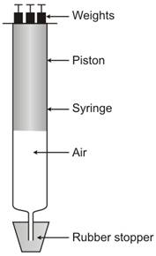
Pressure-volume relationship

- The molecular motion is directly proportional to the temperature.
As temperature increases, molecular motion increases because the molecule possesses certain kinetic energy. And as the temperature decreases, molecular motion also decreases. Thus, when temperature is zero, molecular motion stops or ceases.

- The three variables for gas laws are : 1. Volume, V
2. Pressure, P
3. Temperature, T
These three are called as the Standard variables. S.I. unit of volume is cubic meter (m³).
S.I. unit of pressure is Pascal (Pa).
S.I. unit of temperature is Kelvin (K) or degree Celsius (^{O}C).

- Boyle's law: At constant temperature, the volume of a definite mass of any gas is inversely proportional to the pressure of the gas. Or
Temperature remaining constant, the product of the volume and pressure of the given mass of a dry gas is constant.
Mathematical representation:
According to Boyle's Law,
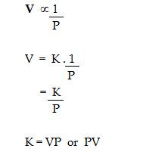
Where K is the constant of proportionality if V' and P' are some other volume and pressure of the gas at the same temperature then,
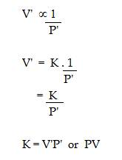
Graphical representation of Boyle's Law:
1. 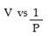: Variation in volume (V) plotted against (1/P) at a constant
temperature, a straight line passing through the origin is obtained.
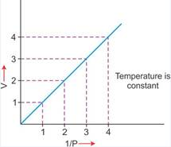
2. V vs P : Variation in volume (V) plotted against pressure (P) at a constant temperature, a hyperbolic curve in the first quadrant is obtained.
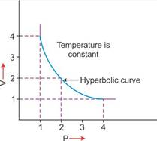
3. PV vs P : Variation in PV plotted against pressure (P) at a constant temperature, a straight line parallel to X-axis is obtained.
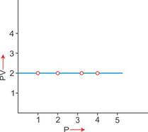
Significance of Boyles law:
According to Boyles law, on increasing pressure, volume decreases. The gas becomes denser. Thus, at constant temperature, the density of a gas is directly proportional to the pressure.
At higher altitude, atmospheric pressure is low so air is less dense. As a result, lesser oxygen is available for breathing. This is the reason that the mountaineers have to carry oxygen cylinders with them.

- Explanation of Boyle's Law on the basis of kinetic theory of matter.
According to kinetic theory of matter, the number of particles present in a given mass and the average kinetic energy is constant.
If the volume of given mass of a gas is reduced to half of its original volume. The same number of particles will have half space to move.
As a result, the number of molecules striking the unit area of the walls of the container at given time will get doubled of the pressure will also get doubled.
Alternatively, if the volume of a given mass of a gas is doubled at constant temperature, same number of molecules will have double space to move. Thus, number of molecule striking the unit area of the walls of container at a given time will become one half of original value. Thus, pressure will also get reduced to half of original pressure. Hence, it is seen that if pressure increases, volume of a gas decreases at constant temperature and this is Boyle's law.

- (a) Pressure will be doubled. (b) Pressure remains the same.

- Charless Law
At constant pressure, the volume of a given mass of a dry gas increases or decreases by 1/273 of its original volume at 00C for each degree centigrade rise or fall in temperature.
V T (At constant pressure)
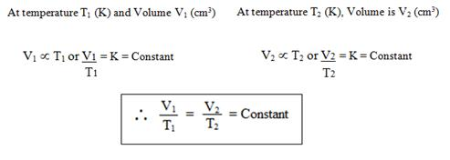For Temperature = Conversion from Celsius to Kelvin
1 K = ^{O}C + 273
For example,
20ºC = 20 + 273 = 293 K
Graphical representation of Charles law
T vs V: The relationship between the volume and the temperature of a gas can be plotted on a graph, A straight line is obtained.
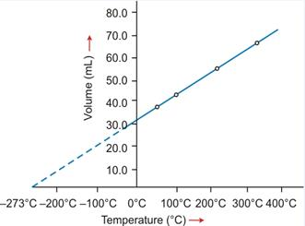
Graphical representation of Charles law
Significance of Charles' Law: Since the volume of a given mass of gas is directly proportional to its temperature, hence the density decreases with temperature. This is the reason that:
(a) Hot air is filled in the balloons used for meteorological purposes. (b) Cable wires contract in winters and expand in summers.

- Explanation Of Charles' Law on the basis of kinetic theory of matter is as follows:
According to kinetic theory of matter, the average kinetic energy of the gas molecules is directly proportional to the absolute temperature. Thus, when the temperature of a gas is increased, the molecules would move faster and the molecules will strike the unit area of the walls of the container more frequently and vigorously. If the pressure is kept constant, the volume increases proportionately. Hence, at constant pressure, the volume of a given mass of a gas is directly proportional to the temperature (Charles' law).

- Absolute zero
The temperature - 273ºC is called absolute zero.
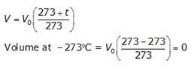
Absolute or Kelvin scale of temperature
The temperature scale with its zero at - 273oC and each degree equal to one degree on the Celsius scale is called Kelvin or the absolute scale of temperature.
Conversion of temperature from Celsius scale to Kelvin scale and vice versa
The value on the Celsius scale can be converted into Kelvin scale by adding 273 to it.
For example,
20ºC = 20 + 273 = 293 K

- (a) The behaviour of gases shows that it is not possible to have temperature below 273.15C. This act has led to the formulation of another scale known as Kelvin scale. The real advantage of the Kelvin scale is that it makes the application and the use of gas laws simple. Even more significantly, all values on the Kelvin scale are positive.
(b) The boiling point of water on the Kelvin scale is 373 K.
Now, K = C + 273 and C = K - 273
Kelvin scale can be converted to degree Celsius by subtracting 273 from it. So, boiling point of water on centigrade sale is : 373 K - 273 = 100C

- (a) Standard or Normal Temperature and Pressure (S.T.P. or N.T.P.)
The pressure of the atmosphere which is equal to 76 cm or 760 mm of mercury is referred to as S.T.P. or N.T.P. The full form for S.T.P. is Standard Temperature and Pressure or Normal Standard temperature and pressure denotes 0ºC or 273K.
Value: The standard values chosen are 0ºC or 273 K for temperature and 1 atmospheric unit (atm) or 760 mm of mercury for pressure.
The standard values chosen are 0ºC or 273 K for temperature and 1 atmospheric unit (atm) or 760 mm of mercury for pressure.
Standard temperature = 0ºC = 273 K
Standard pressure = 760 mm Hg
= 76 cm of Hg
= 1 atmospheric pressure (atm)
(b) Because the volume of a given mass of dry enclosed gas depends upon the pressure of the gas and temperature of the gas in Kelvin so to express the volume of the gases we compare these to S.T.P.

- (a)
(i) C = OC (ii) K = 273K
(b)
(i) 1 atm (ii) 760 mm Hg (iii) 76 cm Hg. (iv) 1, torr = 133.32 Pascal

- Temperature on
Kelvin scale (K) = 273 + Temperature on Celsius scale
Or K = 273 + ^{O}C
(i) 273C in Kelvin
t ^{O}C = t K - 273
273^{O}C = t K - 273
T K = 273 + 273 = 546 K
273^{O}C = 546 K
(ii) 293 K in ^{O}C
t ^{O}C = 293 - 273
t ^{O}C = 20^{O}C
293 K = 20^{O}C

- (a) Charles's Law
(b) Boyles Law

- (a) The real advantage of the Kelvin scale is that it makes the application and use of gas laws simple. Even more significantly, all values on the scale are positive. Thus, removing the problem of negative (-) values on the Celsius scale.
(b) The mass of a gas per unit volume is very small due to the large intermolecular spaces between the molecules. Therefore, gases have low density. Whereas in solids and liquids, the mass is higher and intermolecular spaces are negligible.
(c) At a given temperature, the number of molecules of a gas striking against the walls of the container per unit time per unit area is the same. Thus, gases exert the same pressure in all directions.
(d) Since the volume of a gas changes remarkably with change in temperature and pressure, it becomes necessary to choose standard value of temperature pressure.
(e) According to Boyle's Law, the volume of a given mass of a day gas is inversely proportional to its pressure at constant temperature.
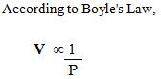
When a balloon is inflated, the pressure inside the balloon decreases and according to Boyle's Law, the volume of the gas should increase. But this does not happen. On inflation of a balloon along with reduction of pressure of air inside balloon, the volume of air also decreases. And this violates Boyle's law.
(f) Atmospheric pressure is very low at high altitudes, volume of air increases thus air becomes less dense. Because volume is inversely proportional to density. Hence, lesser volume of oxygen is available for breathing. Thus, mountaineers have to carry oxygen cylinders with them.
(g) In gas as inter-particle attraction is weak and inter-particle space is so large that the particles become completely free to move randomly in the entire available space and takes the shape of the vessel in which it is kept.

- The temperature scale with its zero at -273^{O}C and where each degree is equal to degree on the Celsius scale is called the absolute scale of temperature.
The temperature -273^{O}C is called the absolute zero. Theoretically, this is the lowest temperature that can never be reached. At this temperature all molecular motion ceases.
The temperature - 273^{O}C is called absolute zero.

- Gases like nitrogen, hydrogen are collected over water as shown in the figure. When the gas is collected over water. The gas is moist and contains water vapour. The total pressure exerted by this moist gas is equal to the sum of the partial pressures of the dry gas and the pressure exerted by water vapour: The partial pressure of water vapour is also known as Aqueous tension.
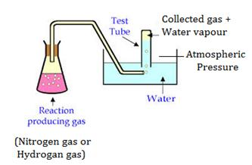
Collection of gas over water
P_{total} = P_{gas} + P_{water vapour}
P_{gas} = P_{total} - P_{water vapour}
Actual Pressure of gas = Total pressure - Aqueous tension

- (a) The volume of gas is zero.
(b) The absolute temperature is 7 + 273 = 280 K
(c) The gas equation is-
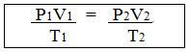
(d) Ice point = 0 + 273 = 273 K
(e) Standard Temperature is taken as 273 K or OC
Standard pressure is taken as 1 atmosphere (atm) or 760 mm Hg.

- (a) (iii) Straight line paralled to X- axis.
(b) (ii) 27C = 27 + 273 = 300 K
(c) (iv) Charles
(d) (ii) 1/2 times

Column A | Column B
(a) Cm³ | Volume
(b) Kelvin | Temperature
(c) Torr. | Pressure
(d) Boyles law | PV = P₁ V₁
(e) Charles's law | 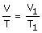

- (a) Volume of a gas is directly proportional to the pressure at constant temperature. (b) Volume of a fixed mass of a gas is inversely proportional to the temperature, the pressure remaining constant.
(c) -273C is equal to zero Kelvin. (d) Standard temperature is 0ºC
(e) The boiling point of water is -373 K.

- (a) Absolute temperature
(b) Absolute zero
(c) Volume
(d) 273

Exercise.
- Given: V = 800 cm³ P = 650 m P₁ = ?
.
V₁ = reduced volume = 40% of 800
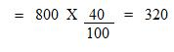
Net V₁ = 800 - 320 = 480 cm³
T = T₁
Using gas equation, we get,
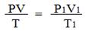
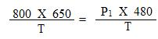
Since, T = T1
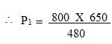
= 1083.33 mm of Hg.

- Let, V₁ = x V₂ = ?
P₁ = 1 atm. P₂ = 2 atm.
T₁ T₂ = 3 T₁
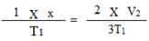
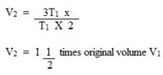

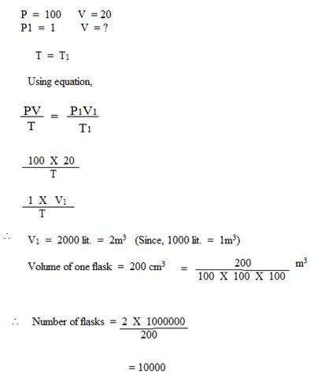
Number of flasks = 10000

- V = 20 lit. P = 29 atm
P 1 = 1.25 atm V₁ =?
t = t₁
Using gas equation,
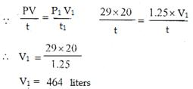

- (a)
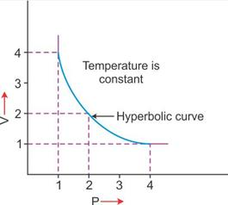P vs V
(b)
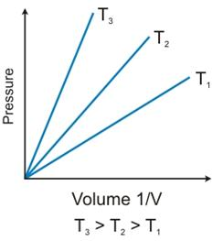
P vs 1/V
(c)
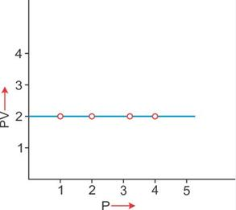
PV vs P
At .9 atmosphere volume = 24.9 liters
At 1 atmosphere volume = 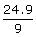
= 27.67 atm.

- V = 3 liters t = 0ºC = 0 + 273 = 273 K
V₁ = ?
T₁ = -20^{O}C = -20^{O} + 273 = 253 K
P = P₁
Using gas equation,
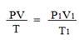
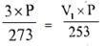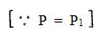
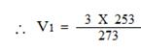
= 2.78 liters
V₁ = 2.78 liters

- (a)
V = 2 liters P =760 mm
V₁ = 4 Dm³ = 4 X l0m X 10m X 10m = 4000 m³ [since, 1 Dm³ = 1000 m³]
= 4 lit. [Since, l lit = 1000 m³]
P₁ = ?
t = t₁
Using gas equation,
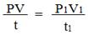
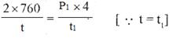
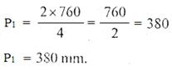

- V = 500 cm³
Normal temperature, t = 0^{O}C = 0 + 273 K
V₁ = Reduced volume + 20% of 500 cm³
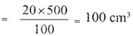
Net, V₁ = 500 - 100 = 400 cm³
T₁ = ?
P = P₁
Using gas equation, we get,
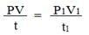
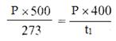
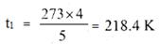
= - 52.60^{O}C

- V = 30 cm³
t = 15C = 15 + 273 = 288 K P = 740 mm
At S.T.P.
V₁ = ?
t₁ = 0C = 273 K P₁ = 760 mm
Using gas equation, 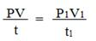
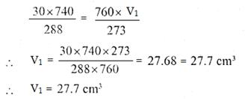

- P = 770 mm V = 88 cm³ P₁ = 880 mm V₁ = ?
t = t₁
Using gas equation,
Or 770 X 88 = V₁ X 880
V₁ = 77 cm³
Volume diminished = 88 - 77 = 11 cm³

- Pressure of dry hydrogen P = 750 - 14 = 736 mrn V = 50 cm
t = 17C = 17 + 273 = 290 K
P₁ = 760 mm
V = ?
T₁ = 0^{O}C = 273 K
Using gas equation,
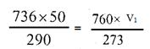
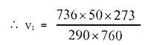
= 45.85 cm³
Let us say (By rounding up),
= 45.6 cm³

- t = C = 273 K P = 760 mm
V = 100 cm
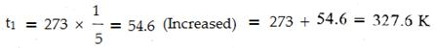
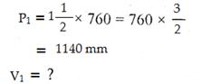
Using gas equation,
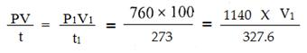
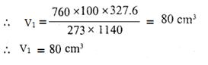

- Let original volume (V) = 1 and original pressure (P) = 1 and temp given (t) = - 15C = - 15 + 273 = 258 K
V₁ or New volume after heating = original volume + 50% of original volume
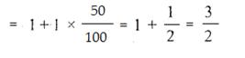
P₁ or decreased Pressure = 60%
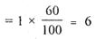
t₁ = To be calculated.
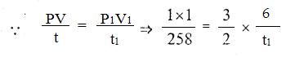
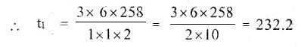
t₁ X 10 = 9 X 258 = 2322
t₁ + 232.2
t₁ = 232.2 - 273 = -40.8^{O}C.

- V = 2 lit.
P = 100 pascal t = 27C = 273 + 27 = 7300 K
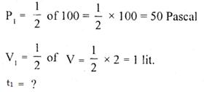
Using gas equation,
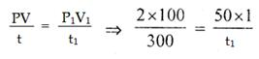
t₁ = 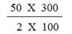
t₁ = 25 X 3 = 75 K
t₁ = 75 - 273
t₁ = - 198^{O}C

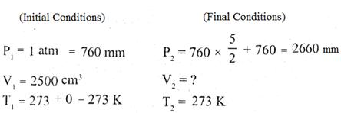
Applying general gas equation,
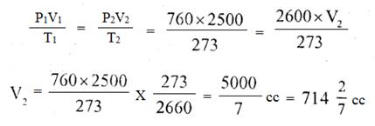
= 5000/7 cm³

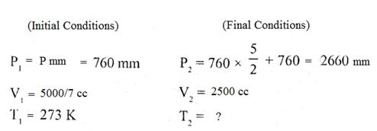
Applying general gas equation,
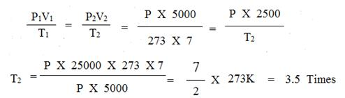

- (a)
Initial Condition Final Condition
V₁ = Vcc V₂ = Vcc
P₁= 100 cm of Hg P₂ = 10 cm of Hg
T₁ = 0 C = 273K T₂ =?
Applying general gas equation,
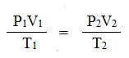
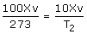
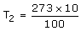
T₂ = 27.3 K
(b) Initial Conditions Final Conditions
V₁ = Vcc V₂ = Vcc
P₁= 100 cm of Hg P₂ = ?
T₁ = 0 + 273 = 273K T₂ = 273 + 100 = 373 K
Applying general gas equation,
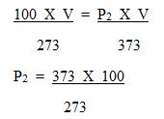
P₂ = 136.63 cm of Hg

- Capacity of the cylinder V = 10000 lit.
P = 800 mm
t = - 3C= - 3 + 273 = 270 K P₁ = 400 mm of Hg
t₁ = 0 C = 0 + 273 = 273 K
V₁ = ?
Using gas equation,
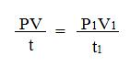
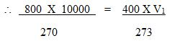
V₁ = 800 X 10000 X 273
270 X 400
= 20222.2 lit.
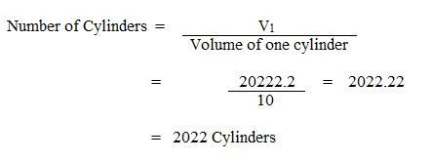

- Volume of 1 mole of gas at STP = 22.4 lit.
V₁ = 22.4 liters V₂ = ?
T₁ = 273 K T₂ = 27 + 273 = 300 K
P₁ = 1 atm P₂ = 4 atm
Using gas equation,
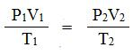
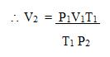
= 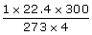
= 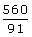
V₂ = 6.15 Liters

- Applying equation,
P₁ = 760 mm P₂ = 50% of P₁ = 50 X 760 = 380 mm
V₁ = V₁ V₂ = 2V₁
t₁ = 273 K t₂ = ?
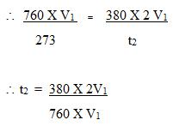
t₂ = 273 K

- (a) P = 748 mm Hg V = 1.2l
T = 25C = 25 + 273 K = 298 K
P₁ = 760 mm of Hg
V₁ = ?
T₁ = 273 K
Applying general gas equation,
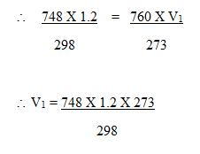
= 1.081 liters
(b)
P = 760 mm Hg P₁ = 760 mm Hg V = 1.25l V₁ = ?
T = 273 K T₁ = 273 K
Applying general gas equation,
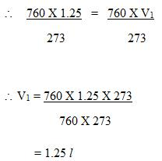
1.25 l O₂ at S.T.P. will have greater volume than 1.2 l N₂ at 25^{O}C and 748 mm Hg, when the 2 gases are compared at S.T.P.

- P₁ = 1 bar P₂ = ?
V₁ = 500 dm3 V₂ = 200 dm3
T₁ = 273 K T₂ = 273 + 30 = 303 K
Using gas equation,
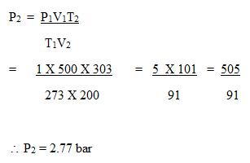

- (i) V₁ = 0.4 L V₂ = 0.4 X 2L
T₁ = 17^{O}C (17 + 273) = 290 K T₂ = ?
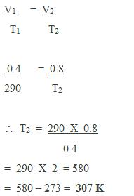
(ii) V₁ = 0.4 L V₂ = 0.2L
T₁ = 17^{O}C (17 + 273) = 290 K T₂ = ?
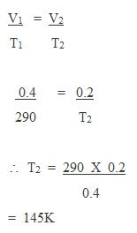
= 145 - 273 = - 128^{O}C

- Pressure due to dry air,
P = 750 - 12 = 738 mm
V = 28 cm3
t = 14C = 14 + 273 = 287 K
P₁ = 760 mm of Hg
V₁ = ?
t₁ = 0^{O}C = 273 K
Using gas equation,
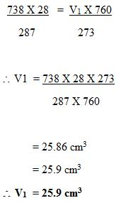

- Step 1: To convert the volume of the gas to S.T.P.
Initial conditions Final Conditions
P₁ = 760 mm P₂ = 760 mm
V₁ = 20 L V₂ = ?
T₁ = 273 + 27 = 300 K T₂ = 273 K
Applying general gas equation,
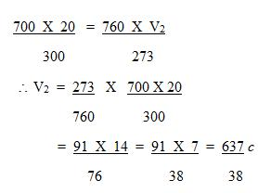
Step 2: To calculate weight of the gas.
