Class 10 –ICSE
Chapter 3-Acid-Bases and Salts
Intext 1
- (a) Acids are defined as compounds which contain one or more hydrogen atoms, and when dissolved in water, they produce hydronium ions (H₃O⁺), the only positively charged ions.
(b) Hydronium ion
(c) H₃O⁺
- Hydronium ions: They are formed by the reaction of H⁺ (from acid) and water. It reacts with water to form H₃O⁺ (Hydronium ion).
Ionization of sulphuric acid showing the formation of hydronium ion:

- If water is added to a concentrated acid, the heat generated causes the mixture to splash out and cause severe burns. Thus, water is never added to acid in order to dilute it.

- Basicity: The basicity of an acid is defined as the number of hydronium ions (H₃O⁺) that can be produced by the ionization of one molecule of that acid in aqueous solution.
The basicity of following compounds are:
Nitric acid:Basicity= 1
Sulphuric acid: Basicity=2
Phosphoric acid: Basicity=3

- (a) Oxyacids: - HNO₃, H₂SO₄
(b) Hydracid:- HCl, HBr
(c) Monobasic acid:- HCl, HBr
(d) Dibasic acid: - H₂SO₄ , H₂CO₃
(e) Tribasic acid:- H₃PO₄, H₃PO₃

- (a) The anhydride of following acids are:
(i) Sulphurous acid: SO₂
(ii) Nitric acid: N₂O₅
(iii) Phosphoric acid: P₂O₅
(iv) Carbonic acid : CO₂
(b) Acids present in following are:
Vinegar: Acetic acid
Grapes: Tartaric acid and Malic acid
Lemon: Citric acid
(c) (i) H⁺ ion turns blue litmus red.
(ii) OH⁻ ion turns red litmus blue.
- Acetic acid is a monobasic acid which on ionization in water produce one hydronium ion per molecule of the acid.

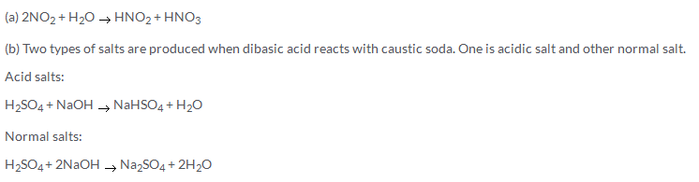

- The strength of an acid is the extent to which the acid ionizes or dissociates in water.
The strength of an acid depends on the degree of ionization and concentration of hydronium ions [H₃O⁺] produced by that acid in aqueous solution.

- (a)Carbonic acid is a dibasic acid with two replaceable hydrogen ions; therefore it forms one acid salt or one normal salt.
Hydrochloric acid is a monobasic acid with one replaceable hydrogen ion and so forms only one normal salt.
(b) Strength of an acid is the measure of concentration of hydronium ions it produces in its aqueous solution. Dil. HCl produces high concentration of hydronium ion compared to that of concentrated acetic acid. Thus, dil. HCl is stronger acid than highly concentrated acetic acid.
(c) H₃PO₃ is not a tribasic acid because in oxyacids of phosphorus, hydrogen atoms which are attached to oxygen atoms are replaceable. Hydrogen atoms directly bonded to phosphorus atoms are not replaceable.

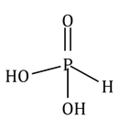
(d) The salt produced is insoluble in the solution so the reaction does not proceed. Hence, we do not expect lead carbonate to react with hydrochloric acid.
(e) NO₂ is called double acid anhydride because two acids – nitrous acid and nitric acid – are formed when it reacts with water.
2NO₂ + H₂O → HNO₂ + HNO₃

- Acid rain is a by-product of a variety of human activities which release oxides of sulphur and nitrogen in the atmosphere. Burning of fossil fuels, coal, oil, petrol and diesel produces sulphur dioxide and nitrogen oxide which pollute the air. Polluted air also contains many oxidising agents which produce oxygen because of excessive heat. This oxygen combines with the oxides of sulphur and nitrogen and rain water to form acids.
2SO₂ + O₂ + 2H₂O → 2H₂SO₄
4NO₂ + O₂ + 2H₂O → 4HNO₃
- Acids are prepared from non-metals by their oxidation. For example :
Sulphur or phosphorus is oxidized by conc. Nitric acid to form sulphuric acid or phosphoric acid.

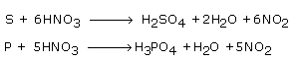
Acids are prepared from salt by displacement reaction. For example :
Nitric acid is prepared by using H₂SO₄ and sodium chloride.
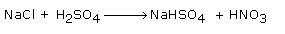

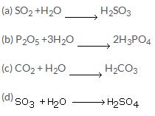
- (a) Citric acid
(b) Carbonic acid
(c) Oxalic acid
(d) Boric acid

Intext 2
- An alkali is a basic hydroxide which when dissolved in water produces hydroxyl ions (OH⁻) as the only negatively charged ions.
(a) Strong alkalis: Sodium hydroxide , Potassium hydroxide
(b) Weak alkalis: Calcium hydroxide , Ammonium hydroxide

- (a) An alkali and a base:
1. Alkalis are soluble in water whereas bases may be or may not be soluble in water.
2. All alkalis are bases but all bases are not alkalis.
(b) An alkali and metal hydroxide :
1. Alkalis are soluble in water whereas metal hydroxides may be or may not be soluble in water.
- (a) An acid: Acids are defined as compounds which when dissolved in water produce hydronium ions.
(b) An alkali: Alkalis are compounds which when dissolved in water produces hydroxyl ions.
- (a) Bases in solution give hydroxide ion.
(b) Weak alkali gives hydroxide ions.
(c) An acid gives a hydronium ion.

- (a) Barium oxide
(b) Sodium hydroxide
(c) Manganese oxide
(d) Cupper hydroxide
(e) Carbonic acid
(f) Ferric hydroxide
(g) Copper oxide
(h) Ammonia
(i) Ammonium hydroxide

- The test tube containing distilled water does not affect the red litmus paper.
The test tube containing acidic solution does not change the red litmus paper.
But the test tube containing basic solution turns red litmus paper blue.

- It is because HCl and HNO₃ ionize in aqueous solution whereas ethanol and glucose do not ionize in aqueous solution.
- It is because HCl ionizes only in aqueous solution.
- Lead oxide is not a base because when it reacts with acid it forms chlorine along with salt and water. Thus, it is excluded from the class bases.
- (a) As the concentration of [H₃O⁺] increases in solution, the pH decreases. Consequently, the acidity of the solution increases.
(b) Yes, basic solutions also have H+ (aq) ions. Basic solutions have lower concentration of H+ (aq) in comparison to concentration of OH-(aq) ions.

- (a) We can obtain a base from another base by double decomposition. The aqueous solution of salts with base precipitates the respective metallic hydroxide.
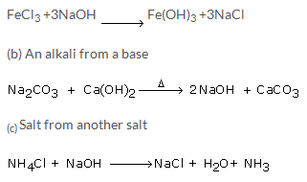

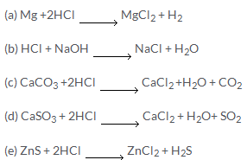
- As we know that alkalis react with oil to form soap. As our skin contains oil so when we touch strong alkalis, a reaction takes place and soapy solution is formed. Hence we should wear gloves.
- Alkalis are soapy to touch as they react with oils of our skin to form soaps.
pH of a solution is the negative logarithm to the base 10 of hydrogen ion concentration expressed in moles per litre.

Indicator | Neutral | Acidic | Alkaline
Litmus  Phenolphthalein | Purple  Colourless | Blue to red  Colourless | Red to blue  Pink

- The solution Y will give a pink colour with phenolphthalein.
- A = Strongly acidic
B= neutral
C=Weakly alkaline
D= Strongly alkaline
E= Weakly acidic
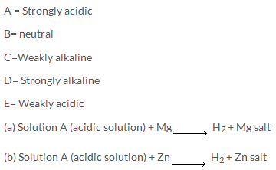
- (a) The p H scale ranges from 0 to 14.
p H = 7 , Solution is neutral
p H <7 , Solution is acidic
p H >7 , Solution is basic
(b) One advantage of measuring the pH of unknown solution by using pH paper is that we can come to know whether the solution is acidic, basic or neutral without wasting the solution.

- (a) A common acid base indicator and a universal indicator:
Acid base indicator like litmus tells us only whether a given substance is an acid or a base. Universal indicator gives an idea as to how acidic or basic a substance is. An universal indicator gives different colours with solutions of different p H values.
(b) Acidity of bases and basicity of acids
Acidity of bases: The number of hydroxyl ions which can be produced per molecule of the base in aqueous solution.
Basicity of acid: The basicity of an acid is defined as the number of hydronium ions that can be produced by the ionization of one molecule of that acid in aqueous solution.
(c) Acid and alkali:
An acid is that substance which gives H⁺ ions when dissolved in water
An alkali is that substance which gives OH⁻ ions when dissolved in water.

- Substances like chocolates and sweets are degraded by bacteria present in our mouth. When the p H falls to 5.5 tooth decay starts. Tooth enamel is the hardest substance in our body and it gets corroded. The saliva produced by salivary glands is slightly alkaline, it helps to increase the p H , to some extent, but tooth paste which contain basic substance is used to neutralize excess acid in the mouth.
- A universal indicator is a mixture of dyes which identify a gradual change of various colours over a wide range of pH, depending on the strength of the acid. When we use a universal indicator, we see solutions of different acids produce different colours. Indeed, solutions of the same acid with different concentration give different colours.
The more acidic solutions turn universal indicator bright red. A less acidic solution will only turn it orange-yellow. Colour differences can also be observed in case of vinegar which is less acidic and battery acid which is more acidic.
Intext 3
- Acidic salt: Acid salts are formed by the partial replacement of the ionizable hydrogen atoms of a polybasic acid by a metal or an ammonium ion.
Normal salt: Normal salts are the salts formed by the complete replacement of the ionizable hydrogen atoms of an acid by a metallic or an ammonium ion.
Mixed salt: Mixed salts are those salts that contain more than one basic or acid radical.
Examples:
(a) A Normal salt: Na₂SO₄ , NaCl
(b) An acid salt: NaHSO₄ , Na₂HPO₄
(c) A mixed salt: NaKCO₃ , CaOCl₂

- (a) Salt is a compound formed by the partial or total replacement of the ionizable hydrogen atoms of an acid by a metallic ion or an ammonium ion.
(b) An insoluble salt can be prepared by precipitation.
(c) A salt prepared by direct combination is Iron(III) chloride.
Reaction:
(d) The name of the procedure used to prepare a sodium salt such as sodium sulphate is Neutralization of acid with base.
- (a) Calcium sulphate from calcium carbonate:
By decomposition of calcium carbonates by acids.
(b) Lead (II) oxide from lead:
Lead oxide can be prepared from lead by Direct combination.
(c) Lead carbonate from lead nitrate:
Lead carbonate is prepared from lead nitrate by precipitation (double decomposition) with Sodium carbonate.
(d) Sodium nitrate from sodium hydroxide:
Sodium nitrate is prepared from sodium hydroxide by neutralizing it with nitric acid.
(e) Magnesium carbonate from Magnesium chloride:
Magnesium carbonate from Magnesium chloride can be prepared by double decomposition with Sodium carbonate.
(f) Copper (II) sulphate from copper (II) oxide:
Copper sulphate can be prepared from copper oxide by action with sulphuric acid.

- (a) Lead sulphate is prepared from insoluble lead oxide, by first converting lead oxide into soluble lead nitrate with dilute nitric acid and then treating the resulting solution with sulphuric acid to obtain white ppt. of Lead sulphate.
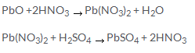
(b) Lead sulfate is insoluble, when lead is added to sulfuric acid it only reacts on the surface. The lead becomes coated with insoluble lead sulfate and the lead in the interior can't react. Therefore lead sulfate cannot be prepared by adding dilute sulfuric acid.
- (a) Copper sulphate crystals from mixture of charcoal and black copper oxide:
The carbon in the charcoal reduces the black copper oxide to reddish-brown copper. The lid must not be removed until the crucible is cool or the hot copper will be re-oxidized by air.
Take dilute sulphuric acid in a beaker and heat it on wire gauze. Add cupric oxide in small quantities at a time, with stirring till no more of it dissolves and the excess compound settles to the bottom.
Filter it hot and collect the filtrate in china dish. Evaporate the filtrate by heating to the point of crystallization and then allow it to cool and collect the crystals of copper sulphate penta-hydrate.
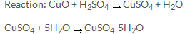
(b) Zinc sulphate crystals from Zinc dust:
Take dilute sulphuric acid in a beaker and heat it on wire gauze. Add some granulated zinc pieces with constant stirring. Add till the Zinc settles at base of the beaker. Effervescences take place because of liberation of hydrogen gas. When effervescence stops, it indicates that all the acid has been used up. The excess of zinc is filtered off. Collect the solution in china dish and evaporate the solution to get crystals. Filter, wash them with water and dry them between the folds of paper. The white needle crystals are of hydrated Zinc sulphate.
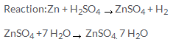
(c) Lead sulphate from metallic lead:
Metallic lead is converted to lead oxide by oxidation. Then lead sulphate is prepared from insoluble lead oxide, by first converting it into soluble lead nitrate. Then the lead nitrate solution is treated with sulphuric acid to obtain white ppt. of Lead sulphate.
Reaction:
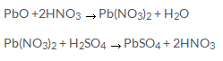
(d) Sodium hydrogen carbonate crystals:
Dissolve 5 grams of anhydrous sodium carbonate in about 25 ml of distilled water in a flask. Cool the solution by keeping the flask in a freezing mixture. Pass carbon dioxide gas in the solution. Crystals of sodium bicarbonate will precipitate out after sometime. Filter the crystals and dry it in folds of filter paper.

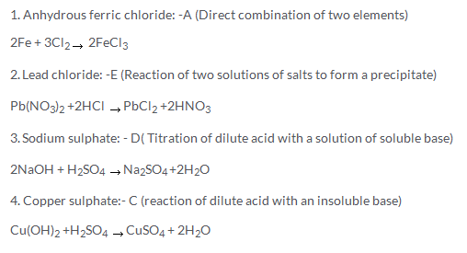
- (a) Lead chloride
(b) Silver chloride
(c) Barium sulphate and lead sulphate
(d) Basic lead chloride
(e) Sodium hydrogen sulphate
(f) Sodium potassium carbonate
(g) Sodium argentocyanide
(h) Potash alum
(i) Potassium bromide and potassium chloride
(j) Calcium sulphate

- The phenomenon, due to which salt formed by a weak acid and a strong base, or by a strong acid and a weak base, reacts with water to give an acidic or an alkaline solution, is known as salt hydrolysis.
(a) Acidic : Iron chloride, Copper sulphate
(b) Basic: Sodium carbonate , potassium acetate
(c) Neutral: Sodium chloride, sodium sulphate

- (a) Blue litmus will turn into red which will indicate the solution to be acidic.
(b) No change will be observed.
(c) Red litmus will turn into blue will indicate the solution to be basic.

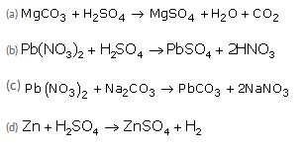

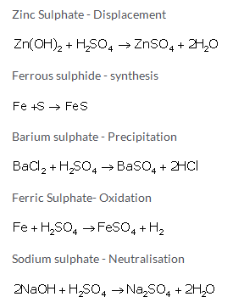

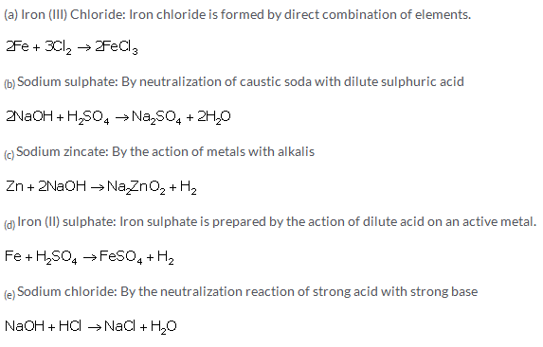
- Neutralization is the process by which H⁺ ions of an acid react completely with the [OH]⁻ ions of a base to give salt and water only.
(b) Neutralization is simply a reaction between H⁺ ions given by strong acid and OH⁻ ions given by strong base. In case of all strong acids and strong bases, the number of H⁺ and OH⁻ ions produced by one mole of a strong acid or strong base is always same. Hence the heat of neutralization of a strong acid with strong base is always same.
- (a) Since sodium hydroxide and sulphuric acid are both soluble, an excess of either of them cannot be removed by filtration. Therefore it is necessary to find out on small scale, the ratio of solutions of the two reactants.
(b) As iron chloride is highly deliquescent, so it is kept dry with the help of fused calcium chloride.

- pH of pure water is 7 at 25ºC. No, the pH does not change when common salt is added.

- Acids: H₂SO₄ and HNO₃
Bases: Ammonium hydroxide and sodium hydroxide.
Salts: Barium chloride and sodium chloride.
Intext 4
- Some salts, while crystallizing out form their solutions, unite with definite quality of water which is known as water of crystallization.
Four substances which contain water of crystallization:
Na₂CO₃.10H₂O Washing soda
MgSO₄.7H₂O Epsom salt
K₂SO₄.Al₂(SO₄)₃.24H₂O Potash alum
Na₂SO₄.10H₂O Glauber's salt

- (a) Efflorescence is the property of some substances to lose wholly, or partly their water of crystallization when their crystals are exposed to dry air even for a short time.
Examples are: Washing soda, Glauber's salt , Epsom salt
(b) Certain water -soluble substances, when exposed to the atmosphere at ordinary temperature, absorb moisture from the atmospheric air to become moist and ultimately dissolve in the absorbed water, forming a saturated solution.
For example: Caustic soda, Caustic potash

Drying agent | Dehydrating agent
i.They remove moisture from other substances.  ii. They are used to dry gases like chlorine, Sulphur dioxide. They are used in desiccators to keep substances dry.  iii.They represent physical change | i. They remove chemically combined elements of water in the ratio of 2:1 from a compound.  ii. They prepare substances like carbon monoxide, sugar charcoal etc.  iii. They represent chemical change

- Conc. H₂SO₄ removes the moisture from gases and it can also remove water molecules from blue vitriol. So conc.H₂SO₄ is used as dehydrating as well as drying agent.
- (i) Blue
(ii) Red
(iii) Hydrogen
(iv) Basic ,Alkaline
(v) Graphite

- (a) Sodium hydrogen sulphate is not an acid but undergoes partial replacement of the ionisable hydrogen atom and behaves as an acidic salt to give H+ ions.
(b) As calcium chloride absorbs moisture and keeps the compound dry, so it is used in desiccators as a drying agent.

- (a) Increases
(b) Increase
(c) Decrease
(d) Increases
(e) Increases

- (a) Common salt contains impurities like magnesium chloride, which are deliquescent substances. So on exposure to air especially during the rainy season, table salt turns moist though sodium chloride is not deliquescent.
(b) This impurity can be removed by passing a current of dry hydrogen chloride gas through a saturated solution of the affected salt. Pure sodium chloride is produced as a precipitate, which can be recovered by filtering and washing first with water and then with alcohol.
(c) Conc. H₂SO₄ can change the blue colour of copper sulphate to white.
(d) Two crystalline substance which do not contain water of crystallization are:
Common salt, Nitre, Sugar.

Misc. Exercise.
- (a) A is sodium salt: It is prepared by neutralization of a base with acids.
(b) B is an insoluble salt: An insoluble salt is obtained from another insoluble salt by double decomposition. The insoluble salt is first converted into a soluble salt which is then used to prepare the desired salt.
(c) C is soluble salt of copper: The soluble salt of copper can be prepared by the decomposition of carbonates by acids.
(d) D is soluble salt of Zinc: The soluble salt of Zinc can be prepared by decomposition of chlorides by conc. H₂SO₄.

(2004)
i) Copper (II) chloride - (B) Action of an acid on an oxide or carbonate
(ii) Iron (II) chloride - (A) Action of acid on metal
(iii) Iron (III) chloride - (C) Direct combination
(iv) Lead (II) chloride - (E) Precipitation (double decomposition)
(v) Sodium chloride - (D) Neutralization of an alkali by an acid

(2005)
(a) The first step is to convert insoluble lead carbonate into soluble lead nitrate by treating lead carbonate with dilute nitric acid.
(c) When dilute sulphuric acid is added directly to lead carbonate, the lead sulphate thus formed will be deposited on solid lead carbonate disconnecting lead carbonate from sulphuric acid.
(2007)
(a) hydronium
(b) hydroxide
(c) salt
(d) water
(e) Hydrogen
(2008)
(i) Complex salts
(ii) Alkali

- (a) (i) The pH increases by the addition of base.
(ii) The pH decreases by the addition of acid.
(b) If the solution changes the colour of litmus from red to blue, the pH indicates the presence of base.
(c) The solution that liberates carbon dioxide from sodium carbonate has pH less than 7.

(2008)
Positively charged
Negatively charged
Salt
Neutralization reaction

(2007)
(a) - (E)
(b) - (A)
(c) -(D)
(d) -(B)
(e) - (C)
(2007)
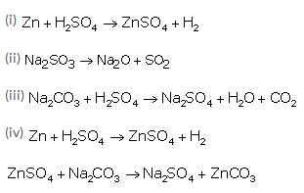
- (a) The name given to the water in the compound copper sulphate-5-water is water of crystallization.
(b) The anhydrous copper sulphate is white in colour.
(c) By adding dehydrating substances such as conc. sulphuric acid as they remove the water of crystallisation.
(d) anhydrous calcium chloride

(2007)
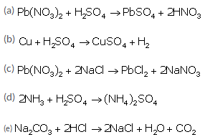
- (a) P
(b) R
(c) Q

- (a) Lead oxide is treated with dilute nitric acid to get soluble Lead nitrate. This Lead nitrate is treated with soluble Metallic chloride or dilute hydrochloric acid to get insoluble Lead chloride.
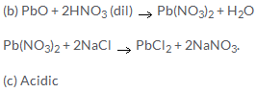
- (a) Sodium sulphate:
Na₂CO₃ + H₂SO₄ (dil) Na₂SO₄ + H₂O + CO₂
(b) Copper sulphate:
CuCO₃ + H₂SO₄ (dil) CuSO₄ + H₂O + CO₂
(c) Iron (II) sulphate:
Fe + H₂SO₄ (dil) FeSO₄ + H₂
(d)Zinc Carbonate:
Zn + H₂SO₄(dil) ZnSO₄ + H₂
ZnSO₄ + Na₂CO₃ ZnCO₃ + Na₂SO₄

- (a) NaHSO₄
(b) AgCl
(c) CuSO₄.5H₂O
(d) CuCO₃
(e) Pb(NO₃)₂

- Acid salt
- 2NaOH +H₂SO ₄Na₂SO₄ +2H₂O
- (a) Alkali
(b) Precipitate
(c) Weak acid

Aqueous solution of HCl | Aqueous solution of NH₃
1. It is acidic in nature.  2. It turns blue litmus to red.  3. It gives Hydronium ions in the solution. | 1. It is basic in nature.  2. It turns red litmus to blue.  3. It gives hydroxyl ions in the solution.

- (a) Fe + 2HCl (dil) FeCl₂ + H₂
(bi) 2Fe (heated) + 3Cl₂ (dry) 2FeCl₃
(c) Fe + H₂SO₄ (dil) FeSO₄ + H₂
(d) Fe + S FeS

