**Class – 10 Concise Physics Solutions Part-II**

**Chapter-1 Force**

**Exercise 1 (A)**

1. Mass of body= 1kg

Initial speed =5m/s

Acceleration due to gravity= 9.8N/kg (vertically downwards)

Force= mass x acceleration

=1 x 9.8 =9.8N= 1kgf

9.8 N or 1 kgf force acts vertically downwards.

1. Mass of body= 1.5 kg

Acceleration due to gravity= 9.8 ms-2

Force = mass (m) x acceleration due to gravity (g)

        = m g

F = 1.50 x 9.8 = 14.7 N

1. (a) Initial velocity, u =0 m/s

Final velocity=v

M1:M2=1:2

From equation: v2-u2=2gh

So, http://cdn.topperlearning.com/topper/bookquestions/187314_image032.gif

http://cdn.topperlearning.com/topper/bookquestions/187314_image034.gif

(b) Force = mg

http://cdn.topperlearning.com/topper/bookquestions/187314_image036.gif

1. Mass of body X= 5kg

Velocity of body X=20m/s

Momentum of body X= mass x velocity

P1= 5 x20=100kgm/s

Mass of body Y=20kg

Velocity of body Y=5m/s

Momentum of body Y=mass x velocity

P2 =20 x 5= 100kgm/s

http://cdn.topperlearning.com/topper/bookquestions/187315_image038.gif

1. Mass= 50g= 0.05kg

Force, F= 20N

Force = mass x acceleration

=ma

http://cdn.topperlearning.com/topper/bookquestions/187316_image040.gif



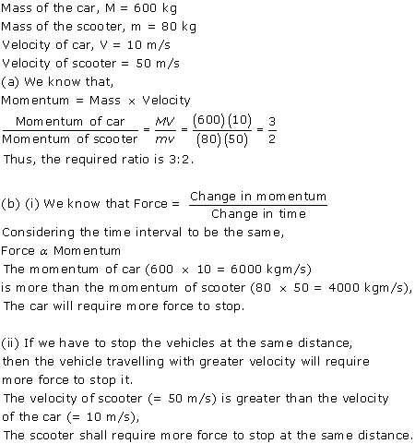

1. Mass of body= 10kg

Force= 2kgf=2 x 9.8=19.6N

Force = mass x acceleration

=ma

http://cdn.topperlearning.com/topper/bookquestions/187318_image044.gif

1. Force = mass x acceleration

=ma

Force F1 = F2

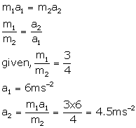

1. (i) Mass of cricket ball, m =100g= 0.1kg

http://cdn.topperlearning.com/topper/bookquestions/187320_image048.gif

Time , http://cdn.topperlearning.com/topper/bookquestions/187320_image050.gif

http://cdn.topperlearning.com/topper/bookquestions/187320_image052.gif

http://cdn.topperlearning.com/topper/bookquestions/187320_image054.gif

(ii) F =mass x acceleration

F= m a

http://cdn.topperlearning.com/topper/bookquestions/187320_image056.gif

1. Mass of bullet=20g =0.020kg

Initial velocity, u=350m/s

Final velocity, v=0m/s

Distance, s=40cm=0.4m

From equation: v2-u2=2as

02-(350)2= 2a x 0.4

Acceleration http://cdn.topperlearning.com/topper/bookquestions/187321_image058.gif

(i) Resistive force, F= mass x acceleration

F= 0.020 x 1.53 x 105

=3062.5N

(ii) Retardation = -acceleration= 1.53 x 105ms-2

1. Mass of body=50g =0.050kg

Initial velocity, u=10m/s

Final velocity, v=0m/s

Resistive force, F=10 N

(i) Force, F= ma

10N=0.050 x a

Acceleration, a= http://cdn.topperlearning.com/topper/bookquestions/187322_image060.gif

Retardation = -acceleration= 200ms-2

(ii)From equation, v2-u2=2as

02-(10)2=2 x (-200)x s

-100 =-400x s

http://cdn.topperlearning.com/topper/bookquestions/187322_image062.gif

1. Mass of toy car=500 g =0.5 kg

Initial velocity, u=25m/s

Final velocity, v= 0m/s

From equation: v= u +at

0=25 + a x 10

Acceleration, a = -2.5ms-2

(a)Retardation = -acceleration= 2.5ms-2

(b)From equation : v2-u2=2as

02-(25)2=2 x (-2.5)x s

-625= -5s

http://cdn.topperlearning.com/topper/bookquestions/187323_image064.gif

( c) Force exerted by brakes, F = m a

F= 0.5 x (-2.5)

= -1.25N

Resistive force exerted by brakes=1.25 N

1. Mass of truck= 5000kg

Initial velocity, u=0m/s

Distance, s=0.5km=500m

Time, t=10 s

(a) From equation :

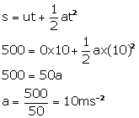

(b) Force = mass x acceleration

F=5000 x 10= 5 x 104N

1. Mass of body =100g=0.1kg

Initial velocity, u=0m/s

Time , http://cdn.topperlearning.com/topper/bookquestions/187325_image068.gif

(a) Force x change in time = change in momentum

Force, F = 10kgf = 10 x 10 = 100N

(http://cdn.topperlearning.com/topper/bookquestions/187325_image070.gif1kgf=10N)

http://cdn.topperlearning.com/topper/bookquestions/187325_image052.gif

100x 0.1=http://cdn.topperlearning.com/topper/bookquestions/187325_image011.gif

http://cdn.topperlearning.com/topper/bookquestions/187325_image011.gif=10 kg m/s

(b) F=100N

Mass=100g=0.1kg

F=ma

100= 0.1 x a

Acceleration, a=1000ms-2

From equation:

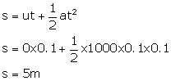

**Exercise 1 (B)**

1. Moment of force= force x perpendicular distance of force from point O

Moment of force= F x r

5Nm= 10 x r

R= 5/10 =0.5 m

1. Length, r=10cm =0.1m

F= 5N

Moment of force= F x r= 5 x 0.1= 0.5 Nm

1. Given , F= 2N

Diameter=2m

Perpendicular distance between B and O =1m

(i) Moment of force at point O

= F x r

=2 x 1=2Nm (clockwise)

(ii) Moment of force at point A= F x r

=2 x 2=4Nm (clockwise)

1. Given AO=2m and OB=4m

(i) Moment of force F1(=5N) at A about the point O

=F1 x OA

=5 x 2= 10Nm (anticlockwise)

(ii) Moment of force F2(=3N) at B about the point O

= F2 x OB

=3 x 4=12 Nm(clockwise)

(iii) Total moment of forces about the mid-point O=

= 12- 10=2Nm(clockwise)

1. Given, AB=4m hence, OA=2m and OB =2m

Moment of force F(=10N) at A about the point O

= F x OA= 10 x 2= 20Nm (clockwise)

Moment of force F (=10N) at point B about the point O

= F x OB= 10 x 2 =20Nm (clockwise)

Total moment of forces about the mid-point O=

= 20 +20= 40Nm(clockwise)

1. (i) Perpendicular distance of point A from the force F=10 N at B is 0.5m , while it is zero from the force F=10N at A

Hence, moment of force about A is

= 10 N x 0.5m=5Nm(clockwise)

(ii) Perpendicular distance of point B from the force F=10 N at A is 0.5m, while it is zero from the force F=10N at B

Hence, moment of force about B is

= 10 N x 0.5m=5Nm(clockwise)

(iii) Perpendicular distance of point O from either of the forces F=10N is 0.25 m

Moment of force F(=10N) at A about O= 10N x 0.25m

=2.5Nm(clockwise)

And moment of force F(=10N) at B about O

=10N x 0.25m=2.5Nm(clockwise)

Hence, total moment of the two forces about O

=0.25 + 0.25=5Nm (clockwise)



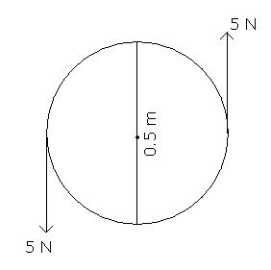

Moment of couple = either force x couple arm

= 5 N x 0.5m

=2.5 Nm

1. Let the 50gf weight produce anticlockwise moment about the middle point of metre rule .i.e, at 50cm.

Let a weight of 100gf produce a clockwise moment about the middle point. Let its distance from the middle be d cm. Then,

according to principle of moments,

Anticlockwise moment = Clockwise moment

50gf x 50 cm=100gf x d

So, d= http://cdn.topperlearning.com/topper/bookquestions/187357_image098.gif

1. (i) Weight mg (W) of rule produces an anti-clockwise moment about the knife edge O. In order to balance it, 20gf must be suspended at the end B to produce clockwise moment about the knife edge O.

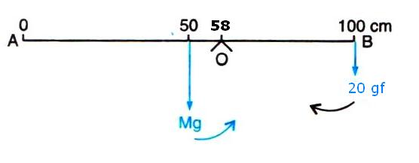

(ii)

From the principle of moments,

Anticlockwise moment= Clockwise moment

W x (58-50) =20gf x (100-58)

W x 8=20gf x 42

W = http://cdn.topperlearning.com/topper/bookquestions/187358_image102.gif

1. Anticlockwise moment= 40gf x 40 cm

Clockwise moment= 80gf x d cm

From the principle of moments,

Anticlockwise moment= Clockwise moment

40gf x 40 cm =80gf x d

So, d = http://cdn.topperlearning.com/topper/bookquestions/187359_image106.gif.

1. (i) Anticlockwise moment= 40gf x (50-10)cm

=40gf x 40cm=1600 gf x cm

Clockwise moment= 20gf x (90- 50) =20gf x 40cm

=800 gf x cm

Anticlockwise moment is not equal to clockwise moment. Hence the metre rule is not in equilibrium and it will turn anticlockwise.

(ii) To balance it, 40gf weight should be kept on right hand side so as to produce a clockwise moment about the middle point. Let its distance from the middle be d cm. Then,

clockwise moment= 20gf x 40cm + 40gf x d cm

From the principle of moments,

Anticlockwise moment= Clockwise moment

40 gf x 40 cm= 20gf x 40 + 40 x d cm

1600-800=40gf x dcm

So, d= http://cdn.topperlearning.com/topper/bookquestions/187360_image110.gif(on the other side)

Hence, by placing the additional weight of 40gf at the 70cm mark the rule can be brought in equilibrium.

1. From the principle of moments,

Anticlockwise moment= Clockwise moment

20kgf x 2m =40kgf x d

So, d= http://cdn.topperlearning.com/topper/bookquestions/187361_image112.giffrom the centre on the side opposite to the boy.

1. From the principle of moments,

Anticlockwise moment= Clockwise moment

100 gf x 40 cm =W x 60 cm

So, weight on the longer pan ,

W= http://cdn.topperlearning.com/topper/bookquestions/187362_image114.gif

1. (i) Total anticlockwise moment about O

= 150gf x 40 cm=6000gf cm

(ii) Total clockwise moment about O,

=250gf x 20 cm= 5000gf cm

(iii) The difference of anticlockwise and clockwise moment= 6000- 5000= 1000gf cm

(iv) From the principle of moments,

Anticlockwise moment= Clockwise moment

To balance it, 100gf weight should be kept on right hand side so as to produce a clockwise moment about the O. Let its distance from the point O be d cm. Then,

150gf x 40 cm=250gf x 20 cm +100gf x d

6000gf cm= 5000gf cm + 100gf x d

1000gf cm =100 gf x d

So, d=http://cdn.topperlearning.com/topper/bookquestions/187363_image118.gifon the right side of O.

1. (i) Anticlockwise moment= 10gf x 50 cm= 500gf cm

(ii) From the principle of moments,

Anticlockwise moment= Clockwise moment

10gf x 50 cm= W x 100cm

So, W= http://cdn.topperlearning.com/topper/bookquestions/187364_image120.gif

By applying a force 5gf upwards at the 100cm mark, rule can be made horizontal

1. (a)

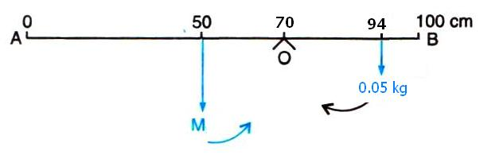

(b)From the principle of moments,

Anticlockwise moment= Clockwise moment

M x 20cm =0.05kg x 24 cm

So, M= http://cdn.topperlearning.com/topper/bookquestions/187365_image124.gif

1. (i) From the principle of moments,

Clockwise moment= Anticlockwise moment

100g x (50-40) cm= m x(40-20) cm

100g x 10 cm = m x 20 cm = m =50 g

(ii) The rule will tilt on the side of mass m (anticlockwise), if the mass m is moved to the mark 10cm.

(iii) Anticlockwise moment if mass m is moved to the mark 10 cm= 50g x (40-10)cm =50 x 30=1500g cm

Clockwise moment=100g x (50-40) cm= 1000g cm

Resultant moment= 1500g cm -1000g cm= 500g cm (anticlockwise)

(iv) From the principle of moments,

Clockwise moment= Anticlockwise moment

To balance it, 50g weight should be kept on right hand side so as to produce a clockwise moment .Let its distance from fulcrum be d cm. Then,

100g x (50-40) cm + 50g x d =50g x (40-10)cm

1000g cm + 50g x d =1500 g cm

50 g x d= 500g cm

So, d =10 cm

By suspending the mass 50g at the mark 50 cm, it can be balanced.

**Exercise 1 (C)**

No Numerical

**Exercise 1 (D)**

No Numerical