**Class – X Concise Physics Solutions-II**

**Chapter- 1 Force**

**Exercise 1 (A)**

2. The forces which act on bodies when they are in physical contact, are called contact forces. For e.g. frictional force and force exerted on two bodies during collision.
3. The forces experienced by bodies even without being physically touched, are called the non-contact forces. For e.g. Gravitational force and Electrostatic force.
4. Contact force: (a) frictional force (b) normal reaction force (c) force of tension in a string

Non-contact force: (d) gravitational force (e) electric force (f) magnetic force

1. (a)Force exerted on two bodies during collision.

(b)Magnetic force between magnetic poles.



(a)

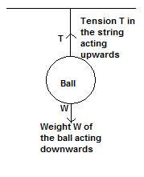

(b)

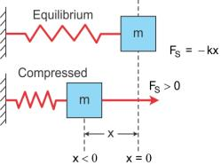

1. The magnitude of a non-contact force depends on distance of separation of two bodies. Magnitude of force decreases as the distance increases.
2. The magnitude of gravitational force between two masses will become four times as gravitational force varies inversely as the square of distance of separation.
3. A force when applied on a non-rigid body changes the inter-spacing between its constituent particles and therefore causes a change in its dimensions and can also produce motion in it.

On the other hand, a force when applied on a rigid body, does not change the inter-spacing between its constituent particles and therefore it does not change the dimensions of the body but causes motion in it

1. (a)A fielder on the ground stops a moving ball by applying a force with his hands.

(b)The pull exerted by horse makes a cart moves.

(c)In a cycle pump, when the piston is lowered, the air is compressed to occupy a less volume.

(d)On pressing a piece of rubber, its shape changes.

1. Newton's first law of motion: A body continues to be in its state of rest or of uniform motion in a straight line unless an external force is applied on it. It is called the law of inertia because it tells that every material body has a property by virtue of which it resists the change in its state of rest or in its state of motion. This property is called inertia.
2. The product of mass and velocity of the body is called linear momentum. S.I. unit of linear momentum is kg m s-1.
3. (i)When v <http://cdn.topperlearning.com/topper/bookquestions/187297_image005.gif.

(ii)When vhttp://cdn.topperlearning.com/topper/bookquestions/187297_image003.gifc, the change in momentum is http://cdn.topperlearning.com/topper/bookquestions/187297_image007.gif.

If velocity v of the moving body is much smaller than the velocity of light c (v<

1. The rate of change of momentum of a body is directly proportional to the force applied on it and this change in momentum takes place in the direction of the applied force, i.e.,

http://cdn.topperlearning.com/topper/bookquestions/187298_image009.gif

where p denotes momentum and http://cdn.topperlearning.com/topper/bookquestions/187298_image011.gifis the change in momentum in timehttp://cdn.topperlearning.com/topper/bookquestions/187298_image013.gif.

1. Newton's second law of motion - The rate of change of momentum of a body is directly proportional to the force applied on it and this change in momentum takes place in the direction of the applied force, i.e.,

http://cdn.topperlearning.com/topper/bookquestions/187299_image009.gif

where p denotes momentum and http://cdn.topperlearning.com/topper/bookquestions/187299_image011.gifis the change in momentum in time http://cdn.topperlearning.com/topper/bookquestions/187299_image013.gif.

When mass m of the body is constant at velocity v (which is much smaller than the velocity of light c) then rate of change of momentum is:

http://cdn.topperlearning.com/topper/bookquestions/187299_image015.gif

F= ma

1. (a)Force

(b)Much less than the velocity of light.

1. The rate of change of momentum = http://cdn.topperlearning.com/topper/bookquestions/187301_image017.gif

(When vhttp://cdn.topperlearning.com/topper/bookquestions/187301_image003.gifc or m is not constant).

But if mass m is constant i.e., v<

rate of change of momentum = http://cdn.topperlearning.com/topper/bookquestions/187301_image020.gif

Here the quantity http://cdn.topperlearning.com/topper/bookquestions/187301_image022.gif= rate of change of velocity i.e., acceleration a.

Rate of change in momentum = http://cdn.topperlearning.com/topper/bookquestions/187301_image024.gif

Thus, by Newton's second law of motion, http://cdn.topperlearning.com/topper/bookquestions/187301_image026.gif

or, F= k ma

where k is a constant of proportionality which can be made equal to 1 by choosing the suitable unit for force.

Hence, F= ma when mass m of the body is constant at velocity v which is much smaller than the velocity of light.

1. S.I unit of

(a) momentum is kg m s-1

(b) rate of change in momentum is newton(N).

1. Force, F= mass (m) x Acceleration (a)

(a)

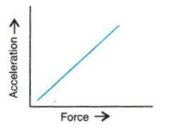

(b)

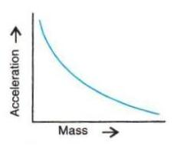

1. (a)Yes, there is a change in momentum of the rocket. Decrease in mass of the rocket causes the

    change in momentum.

(b)Yes, there is force acting on the rocket which is equal to the rate of change in momentum.

1. Third law of motion states that –To every action, there is always an equal and opposite reaction.
2. S.I. unit of force is Newton (N).

One Newton is that force which when acting on a body of mass 1kg, produces an acceleration of 1 m s-2 in it.

C.G.S. unit of force is dyne.

One dyne is that force which when acting on a body of mass 1 gram, produces an acceleration of 1 cm s-2 in it.

1 Newton = 105 dyne

1. S.I unit of force is newton (N).

One Newton is that force which when acting on a body of mass 1kg, produces an acceleration of 1 m s-2 in it.

1. One kilogramme force is the force by which the Earth pulls a mass of 1 kilogramme towards itself.

1 kgf = 9.8 N

1. One kilogramme force is the force by which the Earth pulls a mass of 1 kilogramme towards itself.

1 kgf = 9.8 N

1. It means that we have to exert a force of 9.8 N to hold a mass of 1 kg on our palm.
2. (a)Acceleration

(b)105

(c)0.1

(d)Force.

**MCQ**

1. Frictional force

Hint: It is the force which comes in play when two bodies come in contact.

1. F =

**Exercise 1 (B)**

1. (a) When the body is free to move it produces translational motion.

(b) When the body is pivoted at a point, it produces rotational motion.

1. The moment of force is equal to the product of the magnitude of the force and the perpendicular distance of the line of action of force from the axis of rotation.

S.I. unit of moment of force is Newton metre (Nm).

1. Moment of force about a point depends on the following two factors:

(a)The magnitude of the force applied and,

(b)The distance of line of action of the force from the axis of rotation.

1. When the body is pivoted at a point, the force applied on the body at a suitable point rotates the body about the axis passing through the pivoted point.

The direction of rotation can be changed by changing the point of application of force. The given figure shows the anticlockwise and clockwise moments produced in a disc pivoted at its centre by changing the point of application of force F from A to B.

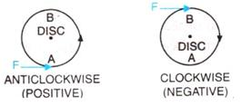

1. Moment of force about a given axis= Force x perpendicular distance of force from the axis of rotation.

1. Moment of force depends on the distance of line of action of the force from the axis of rotation. Decreasing the perpendicular distance from the axis reduces the moment of a given force.

1. If the turning effect on the body is anticlockwise, moment of force is called anticlockwise moment and it is taken as positive while if the turning effect on the body is clockwise, moment of force is called clockwise moment and is taken negative.
3. It is easier to open a door by applying the force at the free end of it because larger the perpendicular distance, less is the force needed to turn the body.
4. The stone of hand flour grinder is provided with a handle near its rim so that it can be rotated easily about the iron pivot at its centre by a small force applied at the handle.
5. It is easier to turn the steering wheel of a large diameter than that of a small diameter because less force is applied on steering of large diameter which is at a large distance from the centre of rim.
6. A spanner (or wrench) has a long handle to produce larger turning moment so that nut can easily be turned with a less force.



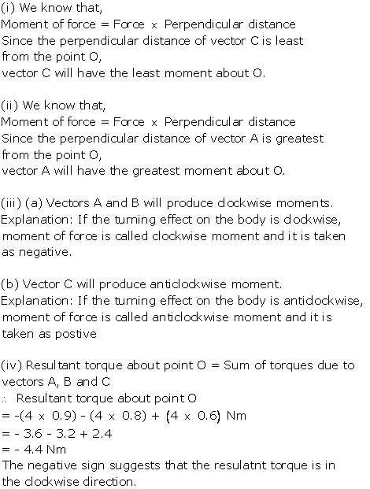



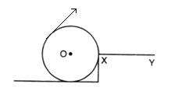

Force F should be provided in the direction as shown in the diagram.

1. (a) Resultant force acting on the body = F-F=0

moment of forces = 0 i.e., no motion of the body

(b) The forces tend to rotate the body about the mid-point between two forces,

Moment of forces= Fr



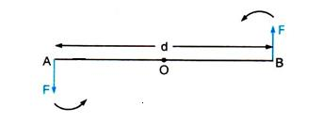

At A and B, two equal and opposite forces each of magnitude F are applied. The two forces rotate the bar in anticlockwise direction.

1. Two equal and opposite parallel forces not acting along the same line, form a couple. A couple is always needed to produce the rotation. For example, turning a key in a lock and turning a steering wheel.

1. The moment of a couple is equal to the product of the either force and the perpendicular distance between the line of action of both the forces. S.I unit of moment of couple is Nm.



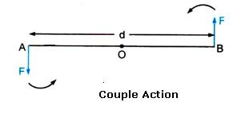

At A and B, two equal and opposite forces each of magnitude F are applied. The two forces rotate the bar in anticlockwise direction. The perpendicular distance between two forces is AB which is called the couple arm.

Moment of force F at the end A

= F x OA (anticlockwise)

Moment of force F at the end B

= F x OB (anticlockwise)

Total moment of couple =F x OA + F x OB

= F x (OA +OB)= F x AB

= F x d (anticlockwise)

=Either force x perpendicular distance between the two forces (or couple arm)

Thus, Moment of couple = Force x Couple arm

1. When a number of forces acting on a body produce no change in its state of rest or of motion, the body is said to be in equilibrium.
2. (i) When a body remains in the state of rest under the influence of the applied forces, the body is in static equilibrium. For example a book lying on a table is in static equilibrium.

(ii) When a body remains in the same state of motion (translational or rotational), under the influence of the applied forces, the body is said to be in dynamic equilibrium. For example, a rain drop reaches the earth with a constant velocity is in dynamic equilibrium.

1. For a body to be in equilibrium:

(i) The resultant of all the forces acting on the body should be equal to zero.

(ii) The resultant moment of all the forces acting on the body about the point of rotation should be zero.

1. According to the principle of moments, if the algebraic sum of moments of all the forces acting on the body about the axis of rotation is zero, the body is in equilibrium. A physical balance (or beam balance) works on the principle of moments.

1. Suspend a metre rule horizontally from a fixed support by means of a strong thread at O as shown. Now suspend two spring balances with some slotted weights W1 and W2 on them on either side of the thread. The scale may tilt to one side. Now adjust the distances of two spring balances from the support by keeping one at A and the other at B in such a way that the scale again becomes horizontal.

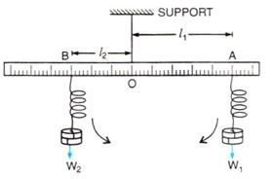

Let the weight suspended on the right side of thread from the spring balance at A be W1 at distance OA=l1, while the weight suspended on the left side of thread from the spring balance at B be W2 at distance OB= l2.

The weight W1 tends to turn the scale clockwise, while the weight W2 tend to turn the scale anticlockwise.

Clockwise moment = W1 x l1

Anticlockwise moment = W2 x l2

In equilibrium, when the scale is horizontal, it is found that

Clockwise moment = Anticlockwise moment

i.e., W1 x l1 = W2 x l2

This verifies the principle of moments.

**MCQ**

1. The moment of a force about a given axis depends on both on the force and its perpendicular distance from the axis.

Hint: Moment of force = Force x Perpendicular distance

1. The body will have rotational as well as translational motion.

**Exercise 1 (C)**

1. Centre of gravity is the point about which the algebraic sum of moments of weights of particles constituting the body is zero and the entire weight of the body is considered to act at this point.
2. Yes, the centre of gravity can be situated outside the material of the body. For example, centre of gravity of ring.
3. The position of centre of gravity of a body of given mass depends on its shape i.e., on the distribution of mass in it. For example: the centre of gravity of a uniform wire is at its mid-point. But if this wire is bent into the form of a circle, its centre of gravity will then be at the centre of circle.
4. The position of centre of gravity of a

(a) rectangular lamina is at the point of intersection of its diagonals.

(b) cylinder is at the mid point on the axis of cylinder.

1. (a) Centre of gravity of a triangular lamina is situated at the point of intersection of its medians.

(b) Centre of gravity of a circular lamina is situated at the centre of circular lamina.

1. Centre of gravity of a uniform ring is situated at the centre of ring.

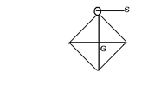

A square card board in rest position with G as centre of gravity and S as point of suspension.

1. Take a triangular lamina. Make three fine holes at a, b, c near the edge of triangular lamina. Now suspend the given lamina along with a plumb line from hole 'a'. Check that the lamina is free to oscillate about the point of suspension. When lamina has come to rest, draw straight line ad along the plumb line. Repeat the experiment by suspending the lamina through hole 'b' and then through hole 'c' for which we get straight lines be and cf respectively. It is noticed that the lines ad, be and cf intersect each other at a common point G which is the position of centre of gravity of triangular lamina i.e. the point of intersection of medians.

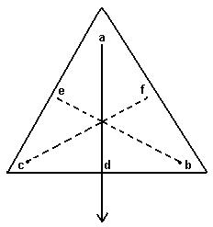

1. (i) False. The position of centre of gravity of a body of given mass depends on its shape i.e., on the distribution of mass in it.

(ii) True.



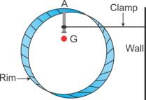



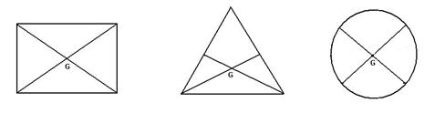

**MCQ**

1. At its geometrical centre

**Exercise 1 (D)**

1. When a particle moves with a constant speed in a circular path, its motion is said to be the uniform circular motion. For example : Revolution of earth around sun is an example of uniform circular motion.
2. Particle moving in a circular path with a constant speed.

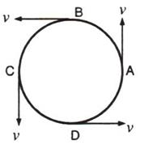

1. Yes, uniform circular motion has an accelerated motion with a constant speed.

1. Motion of a cyclist on a circular track is an example of motion in which speed remains uniform, but the velocity changes.
2. When the object moves in a circular path with uniform speed, it means that its magnitude of velocity does not change, only its direction changes continuously. Hence, it is considered as uniformly accelerated motion.

|  |  |
| --- | --- |
| Uniform linear motion | Uniform circular motion |
| The body moves along a straight line. | The body moves along a circular path. |
| Speed and direction both remain constant. | Speed is constant, but direction changes continuously. |
| It is not an accelerated motion. | It is an accelerated motion. |

1. Centripetal force is required for circular motion. It is always directed towards the centre of circle.
2. Force acting on a body which is in circular motion is called centripetal force. It acts towards the centre of circular path.
3. Force of tension in the thread provides the centripetal force.
4. A planet moves around the sun in a nearly circular path for which the gravitational force of attraction on the planet by the sun provides the necessary centripetal force required for circular motion.
5. (a) They act in opposite directions.

(b) No, centrifugal force is not the force of reaction of centripetal force.

1. No, centrifugal force is a fictitious force.
2. (a) On standing outside the disc, we find that the pebble is moving on a circular path. On standing at the centre of the disc, we find that the pebble is stationary placed just in front of us.
3. (a)False

(b)True

(c)True

(d)False

**MCQ**

1. Speed

Hint: Speed is scalar but velocity and acceleration are vector quantities. So, speed remains constant but velocity and acceleration change with the change in direction, and in circular motion the direction of motion changes at every point.