**Class – 10 Concise Physics Solutions Part-II**

**Chapter-3 Machines.**

**Exercise 3(A)**

1. Total length of crowbar =120 cm

Load arm =20 cm

Effort arm = 120-20 =100 cm

Mechanical advantage http://cdn.topperlearning.com/topper/bookquestions/189332_image045.gif

http://cdn.topperlearning.com/topper/bookquestions/189332_image047.gif

1. Total length of rod=4 m = 400 cm

(a) 18kgf load is placed at 60 cm from the support.

W kgf weight is placed at 250 cm from the support.

By the principle of moments

18 x 60 = W x 250

W = 4.32 kgf

(b) Given W=5 kgf

18kgf load is placed at 60 cm from the support.

Let 5 kgf of weight is placed at d cm from the support.

By the principle of moments

18 x 60 = 5 x d

d = 216 cm from the support on the longer arm

(c) It belongs to class I lever.

1. Effort arm = 7.5 cm

Load arm = 15 cm

Mechanical advantagehttp://cdn.topperlearning.com/topper/bookquestions/189334_image049.gif

1. Effort arm = 10 cm

Load arm = 5 cm

Mechanical advantage=http://cdn.topperlearning.com/topper/bookquestions/189335_image051.gif

Load=5kgf

http://cdn.topperlearning.com/topper/bookquestions/189335_image053.gif

1. (a) This is a class I lever.

(b) Given AB=1m, AF=0.4m and BF=0.6 m

Mechanical advantagehttp://cdn.topperlearning.com/topper/bookquestions/189336_image057.gif

(c) Load =15kgf

http://cdn.topperlearning.com/topper/bookquestions/189336_image059.gif

1. Diagram:

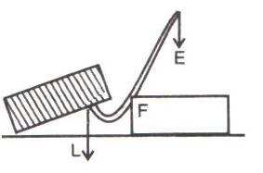

Crowbar is a class I lever.

(i) Total length of crowbar =1.5m

Effort arm = 1 m

Load arm = 1.5-1 =0.5 m

(ii) Effort arm= 1m

(iii) Mechanical advantagehttp://cdn.topperlearning.com/topper/bookquestions/189337_image063.gif

(iv) The effort needed

http://cdn.topperlearning.com/topper/bookquestions/189337_image065.gif

1. Effort arm = 2 cm

Load arm = 8.0 cm

Given effort =10kgf

(i) Mechanical advantage http://cdn.topperlearning.com/topper/bookquestions/189338_image067.gif

(ii) http://cdn.topperlearning.com/topper/bookquestions/189338_image069.gif

The pair of scissors acts as a speed multiplier because MA < 1.

1. Effort arm = 2 cm

Load arm = 8.0 cm

Given effort =10kgf

(i) Mechanical advantage http://cdn.topperlearning.com/topper/bookquestions/189338_image067.gif

(ii) http://cdn.topperlearning.com/topper/bookquestions/189338_image069.gif

The pair of scissors acts as a speed multiplier because MA < 1.

1. (a) The principle of moments: Moment of the load about the fulcrum=moment of the effort about the fulcrum

FB x Load = FA x Effort

(b) Sugar tongs the example of this class of lever.

(c) Given: FA=10 cm, AB = 500 cm, BF =500+10=510 cm.

The mechanical advantage

http://cdn.topperlearning.com/topper/bookquestions/189340_image079.gif

The minimum effort required to lift the load

http://cdn.topperlearning.com/topper/bookquestions/189340_image081.gif

1. (a) (i) Load arm AF=20 cm

     (ii)Effort arm CF=60 cm

     (iii)Mechanical advantage http://cdn.topperlearning.com/topper/bookquestions/189341_image087.gif

     (iv)Total load =30+15 = 45 kgf

http://cdn.topperlearning.com/topper/bookquestions/189341_image089.gif

1. Fire tongs has its arms =20 cm

Effort arm = 15 cm

Load arm =20 cm

(i) Mechanical advantage http://cdn.topperlearning.com/topper/bookquestions/189342_image091.gif

(ii) http://cdn.topperlearning.com/topper/bookquestions/189342_image093.gif.

**Exercise 3B.**

1. Mass of load m= 50 kg

Force required to lift a load 1 meter (h) = mxg = 50x10 = 500N

The maximum effort exerted by boy E =250 N

Load L = 500N

Mechanical advantage http://cdn.topperlearning.com/topper/bookquestions/189351_image099.gif

http://cdn.topperlearning.com/topper/bookquestions/189351_image101.gif

Height (h) =1m

Minimum length of plank l = MA x h = 2x1 = 2m

1. Length of sloping wooden plank l =2.0m

Load =100kgf

Height of inclined plane h =1m

(a) The mechanical advantage of the slopping plank

http://cdn.topperlearning.com/topper/bookquestions/189352_image103.gif

(b) Effort needed to push the drum up into the truck=

http://cdn.topperlearning.com/topper/bookquestions/189352_image105.gif

Assumption: There is no friction between the drum and the plank.

1. Number of teeth in first wheel = 10

Number of teeth in second wheel = 50

For gain in speed, the second wheel of 50 teeth (NA= 50) is used as driving wheel and the first wheel of 10 teeth (NB= 10) is used as driven wheel.

Syntax error from line 1 column 49 to line 1 column 73. Unexpected '<mstyle '.

Syntax error from line 1 column 49 to line 1 column 73. Unexpected '<mstyle '.

For gain in torque, the second wheel of 50 teeth (NB= 50) is used as driven wheel and the first wheel of 10 teeth (NA= 10) is used as driving wheel.

Syntax error from line 1 column 49 to line 1 column 73. Unexpected '<mstyle '.

Syntax error from line 1 column 49 to line 1 column 73. Unexpected '<mstyle '.

1. The radius of driving wheel rA=2cm

The radius of driven wheel rB=20cm

(a) the gear ratio=http://cdn.topperlearning.com/topper/bookquestions/189354_image115.gif=1:10

(b) The number of rotations made per minute by the driving wheel is na= 100

The number of rotations made per minute by the driven wheel nb=http://cdn.topperlearning.com/topper/bookquestions/189354_image117.gif

(c) Number of teeth in driven wheel NB =40

Number of teeth in driving wheel NA=http://cdn.topperlearning.com/topper/bookquestions/189354_image119.gif

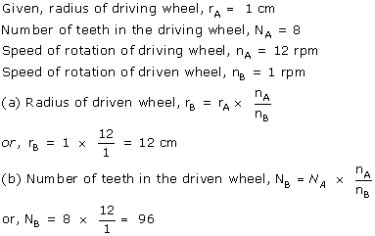

**Exercise 3C.**

1. The force applied by the women is= 70 N

The mass of bucket and water together is = 6 kg

Total load = 6 x 10 = 60 N

Mechanical advantage http://cdn.topperlearning.com/topper/bookquestions/189378_image143.gif

1. Load =500 kgf

Mass of falling object=100kg

Displacement of effort=8.0 m

Time taken=4.0s

(a)Effort =100X10=1000kgf

http://cdn.topperlearning.com/topper/bookquestions/189379_image145.gif

(b)The efficiency of the pulley is= 75%=0.75

Mechanical advantage of this system http://cdn.topperlearning.com/topper/bookquestions/189379_image147.gif

Velocity ratio of this systemhttp://cdn.topperlearning.com/topper/bookquestions/189379_image149.gif

Displacement of load http://cdn.topperlearning.com/topper/bookquestions/189379_image151.gif

1. Load = 75 kgf

Effort=25kgf

n = 3

MA = Load/Effort = 75/25 = 3

or MA = n = 3

velocity ratio VR= n = 3

Efficiency http://cdn.topperlearning.com/topper/bookquestions/189380_image153.gifor 100%



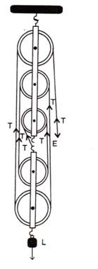

(a) The effort move = 1 x 5 = 5m

(b) Five strands of tackle are supporting the load.

(c) Mechanical advantage of the system =http://cdn.topperlearning.com/topper/bookquestions/189381_image157.gif

1. A block and tackle system has 5 pulleys. (n = 5)

Effort=1000N

Load=4500N

(a) The mechanical advantage http://cdn.topperlearning.com/topper/bookquestions/189382_image159.gif

(b) The velocity ratio = n =5

(c) The efficiency of the system http://cdn.topperlearning.com/topper/bookquestions/189382_image161.gif



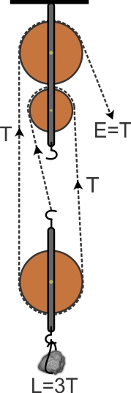

A pulley system has a velocity ratio =3

Efficiency of system= 80 %=0.8

Mechanical advantage of the system http://cdn.topperlearning.com/topper/bookquestions/189383_image165.gif

Effort required to raise the load= http://cdn.topperlearning.com/topper/bookquestions/189383_image167.gif

1. (a)

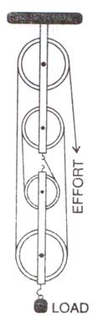

(b) Velocity ratio of the system = n = 4

(c) The relation between load and effort

MA = http://cdn.topperlearning.com/topper/bookquestions/189384_image173.gif

http://cdn.topperlearning.com/topper/bookquestions/189384_image175.gif

(d) (i) There is no friction in the pulley bearings, (ii) weight of lower pulleys is negligible and (iii) the effort is applied downwards.

1. (a) There are 4 strands of tackle supporting the load.

(b)

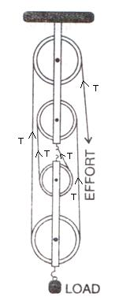

(c) The mechanical advantage of the system

http://cdn.topperlearning.com/topper/bookquestions/189385_image180.gif

(d) When load is pulled up by a distance 1 m, the effort end will move by a distance = 1x4 = 4m.



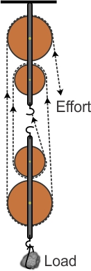

A block and tackle system has the velocity ratio= 3

i.e., VR = n= 3

Efficiency of system http://cdn.topperlearning.com/topper/bookquestions/189386_image182.gif=60%=0.6

The mechanical advantage of the system http://cdn.topperlearning.com/topper/bookquestions/189386_image184.gif

Man can exert a maximum effort= 200 kgf

http://cdn.topperlearning.com/topper/bookquestions/189386_image186.gif



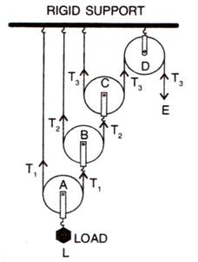

Assumptions: (i) There is no friction in the pulley bearing, (ii) the pulleys and the string are massless.