**Class – X Concise Physics Solutions-II**

**Chapter- 3 Machines**

**Exercise 3A.**

1. A machine is a device by which we can either overcome a large resistive force at some point by applying a small force at a convenient point and in a desired direction or by which we can obtain a gain in the speed.

1. Machines are useful to us in the following ways:

(1) In lifting a heavy load by applying a less effort.

(2) In changing the point of application of effort to a convenient point.

(3) In changing the direction of effort to a convenient direction.

(4) For obtaining a gain in speed.

1. (a) To multiply force: a jack is used to lift a car.

(b) To change the point of application of force: the wheel of a cycle is rotated with the help of a chain by applying the force on the pedal.

(c) To change the direction of force: a single fixed pulley is used to lift a bucket full of water from the well by applying the effort in the downward direction instead of applying it upwards when the bucket is lifted up without the use of pulley.

(d) To obtain gain in speed: when a pair of scissors is used to cut the cloth, its blades move longer on cloth while its handles move a little.

1. The purpose of jack is to make the effort less than the load so that it works as a force multiplier.
2. An ideal machine is a machine whose parts are weightless and frictionless so that which there is no dissipation of energy in any manner. Its efficiency is 100%, i.e. the work output is equal to work input.

|  |  |
| --- | --- |
| **Ideal machine** | **Practical machine** |
| 1. Efficiency is 100%. | 1. Efficiency is less than 100% |
| 2. Its parts are weightless, elastic and perfectly smooth. | 2. Its parts are not weightless, elastic or perfectly smooth. |
| 3. There is no loss in energy due to friction. | 3. There is always some loss of energy due to friction. |
| 4. Work output of such a machine is equal to the work input. | 4. Work output is always less than the work input. |
|  |  |

1. The ratio of the load to the effort is called mechanical advantage of the machine. It has no unit.
2. The ratio of the velocity of effort to the velocity of the load is called the velocity ratio of machine. It has no unit.
3. For an ideal machine mechanical advantage is numerically equal to the velocity ratio.
4. It is the ratio of the useful work done by the machine to the work put into the machine by the effort.

In actual machine there is always some loss of energy due to friction and weight of moving parts, thus the output energy is always less than the input energy.

1. (a) A machine acts as a force multiplier when the effort arm is longer than the load arm. The mechanical advantage of such machines is greater than 1.

(b) A machine acts a speed multiplier when the effort arm is shorter than the load arm. The mechanical advantage of such machines is less than 1.

It is not possible for a machine to act as a force multiplier and speed multiplier simultaneously. This is because machines which are force multipliers cannot gain in speed and vice-versa.

1. Mechanical advantage is equal to the product of velocity ratio and efficiency.

http://cdn.topperlearning.com/topper/bookquestions/189307_image002.gif

For a machine of a given design, the velocity ratio does not change.

1. Let a machine overcome a load L by the application of an effort E. In time t, let the displacement of effort be dE and the displacement of load be dL.

Work input = Effort X displacement of effort

= E X dE

Work output = Load X displacement of load

= L X dL

Efficiency http://cdn.topperlearning.com/topper/bookquestions/189308_image004.gif

http://cdn.topperlearning.com/topper/bookquestions/189308_image006.gif

http://cdn.topperlearning.com/topper/bookquestions/189308_image008.gif

http://cdn.topperlearning.com/topper/bookquestions/189308_image010.gif

http://cdn.topperlearning.com/topper/bookquestions/189308_image012.gif

http://cdn.topperlearning.com/topper/bookquestions/189308_image002.gif

Thus, mechanical advantage of a machine is equal to the product of its efficiency and velocity ratio.

1. The mechanical advantage for an actual machine is equal to the product of its efficiency and velocity ratio.



The efficiency of such a machine is always less than 1, i.e. h<1. This is because there is always some loss in energy in form of friction etc.

1. This is because the output work is always less than the input work, so the efficiency is always less than 1 because of energy loss due to friction.

http://cdn.topperlearning.com/topper/bookquestions/189310_image017.gif

1. A lever is a rigid, straight or bent bar which is capable of turning about a fixed axis.

Principle: A lever works on the principle of moments. For an ideal lever, it is assumed that the lever is weightless and frictionless. In the equilibrium position of the lever, by the principle of moments,

Moment of load about the fulcrum=Moment of the effort about the fulcrum.

1. http://cdn.topperlearning.com/topper/bookquestions/189312_image019.gif

This is the expression of the mechanical advantage of a lever.

1. The three classes of levers are:

(i) Class I levers: In these types of levers, the fulcrum F is in between the effort E and the load L. Example: a seesaw, a pair of scissors, crowbar.

(ii) Class II levers: In these types of levers, the load L is in between the effort E and the fulcrum F. The effort arm is thus always longer than the load arm. Example: a nut cracker, a bottle opener.

(iii) Class III levers: In these types of levers, the effort E is in between the fulcrum F and the load L and the effort arm is always smaller than the load arm. Example: sugar tongs, forearm used for lifting a load.

1. (a) More than one: shears used for cutting the thin metal sheets.

(b) Less than one: a pair of scissors whose blades are longer than its handles.

When the mechanical advantage is less than 1, the levers are used to obtain gain in speed. This implies that the displacement of load is more as compared to the displacement of effort.

1. A pair of scissors and a pair of pliers both belong to class I lever.

A pair of scissors has mechanical advantage less than 1.

1. A pair of scissors used to cut a piece of cloth has blades longer than the handles so that the blades move longer on the cloth than the movement at the handles.

While shears used for cutting metals have short blades and long handles because as it enables us to overcome large resistive force by a small effort.

1. (a) The weight W of the scale is greater than E.

It is because arm on the side of effort E is 30 cm and on the side of weight of scale is 10 cm. So, to balance the scale, weight W of scale should be more than effort E.

(b)

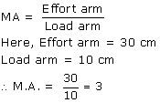

1. Class II lever always have a mechanical advantage more than one.

Example: a nut cracker.

To increase its mechanical advantage we can increase the length of effort arm.

1. Diagram:

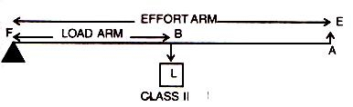

The effort arm is longer than load arm in such a lever.

1. In these types of levers, the load L is in between the effort E and the fulcrum F. So, the effort arm is thus always longer than the load arm. Therefore M.A>1.

1. Diagram:

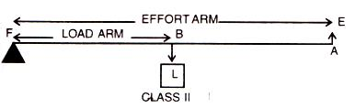

Example: a bottle opener.

1. (a)

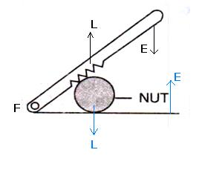

(b)The nut cracker is class II lever.



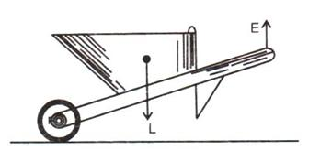

The wheel barrow is a class II lever. One more example of this class is a nut cracker.

1. Classes III levers always have mechanical advantage less than one.

Diagram:

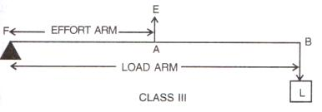

1. In these types of levers, the effort is in between the fulcrum F and the load L and so the effort arm is always smaller than the load arm. Therefore M.A. < 1.
2. With levers of class III, we do not get gain in force, but we get gain in speed, that is a longer displacement of load is obtained by a smaller displacement of effort.
3. (a) Class III.

Here, the fulcrum is the elbow of the human arm. Biceps exert the effort in the middle and load on the palm is at the other end.

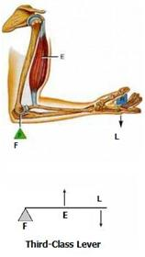

(b) Class II.

Here, the fulcrum is at toes at one end, the load (i.e. weight of the body) is in the middle and effort by muscles is at the other end.

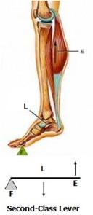



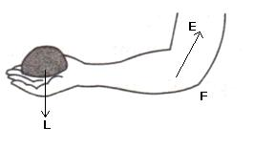

It is Class III lever.

1. Diagram:



Examples: foot treadle.

1. (i) Class I lever in the action of nodding of the head: In this action, the spine acts as the fulcrum, load is at its front part, while effort is at its rear part.

(ii) Class II lever in raising the weight of the body on toes: The fulcrum is at toes at one end, the load is in the middle and effort by muscles is at the other end.

(iii) Class III lever in raising a load by forearm: The elbow joint acts as fulcrum at one end, biceps exerts the effort in the middle and a load on the palm is at the other end.

1. (a) A bottle opener is a lever of the second order, as the load is in the middle, fulcrum at one end and effort at the other.

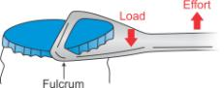

 Bottle opener

(b) Sugar tongs is a lever of the third order as the effort is in the middle, load at one end and fulcrum at the other end.

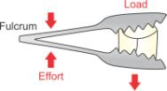

 Sugar tongs

1. (a)A seesaw

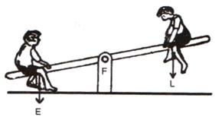

(b)A common balance

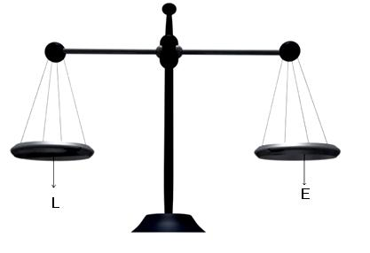

(c)A nut cracker

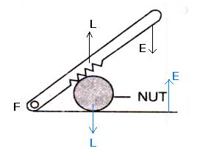

(d)Forceps.

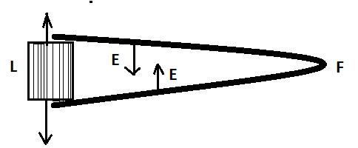

1. a. Class II

b. Class I

c. Class II

d. Class III

**MCQ.**

1. M.A. x E = L
2. M.A. =  Syntax error from line 1 column 49 to line 1 column 73. Unexpected '<mstyle '.x V.R.
3. It can have a mechanical advantage greater than the velocity ratio.

Reason: If the mechanical advantage of a machine is greater than its velocity ratio, then it would mean that the efficiency of a machine is more than 100%, which is practically not possible.

1. Effort is between fulcrum and load

Hint: Levers, for which the mechanical advantage is less than 1, always have the effort arm shorter than the load arm.

1. 

Hint: In class II levers, the load is in between the effort and fulcrum. Thus, the effort arm is always longer than the load arm and less effort is needed to overcome a large load. Hence, 

**Exercise 3B.**

1. Inclined plane: An inclined plane is a sloping surface that behaves like a simple machine whose mechanical advantage is always greater than 1.

Example: the inclined plane is used to load a truck or to take the scooter from road into the house on a higher level. Inclined planes are used to reach the bridge over the railway tracks at a railway station.

1. Since less effort is needed in lifting a load to a higher level by moving over an inclined plane as compared to that in lifting the load directly, an inclined plane acts as a force multiplier. This is because the mechanical advantage of an inclined plane is always greater than 1.

1. The expression for the mechanical advantage of an inclined plane in terms of its length l and vertical height h is:

http://cdn.topperlearning.com/topper/bookquestions/189345_image095.gif

1. Mechanical advantage of an inclined plane is always greater than 1.

4. Gear system: A gear system is a device to transfer precisely the rotator motion from one point to the other. A gear is a wheel with teeth around its rim. The teeth act as the components of a machine and they transmit rotational motion to the wheel by successively engaging the teeth of the other rotating gear.

Working: Each tooth of a gear acts like a small lever of class I. A gear when in operation, can be considered as a lever with an additional property that it can be continuously rotated instead of moving back and forth as is the case with an ordinary lever. Each gear wheel is mounted on an axle which rotates at a speed depending upon the motion transmitted to it. The gear wheel closer to the source of power is called the driver, while the gear wheel which receives motion from the driver is called the driven gear. The driven gear rotates in a direction opposite to the driving gear when the two gears make an external contact. On the other hand, if the gears make an internal contact, both gears rotate in the same direction.

1. (a) A gear system can be used to obtain gain in speed when the bigger wheel drives the smaller wheel, i.e. when the driving gear has more number of teeth than the driven gear.

To obtain gain in speed, the gear ratio should be more than one. Mathematically,



Example: A toy motor car uses the gear principle to obtain gain in speed. It has a key and spring on the axle fitted with a driving gear having more teeth which engages the driven gear having fewer teeth. The wheels of the car are fitted on the axle of the driven gear.

When the key is turned clockwise (or the toy car is pulled back by hand) the spring is wound up. On releasing the key (or the toy car), the spring turns the driving gear anti-clockwise, which in turn rotates the wheels of the toy car clockwise and the car moves forward at a greater speed.

(b) A gear system can be used to obtain gain in torque when the smaller wheel drives the bigger wheel, i.e. when the driving gear has less number of teeth than the driven gear.

To obtain gain in torque, the gear ratio should be less than one. Mathematically,



Example: While ascending a hill, an automobile driver changes gears and puts the driving gear of less number of teeth with a driven gear of more number of teeth. By doing so, he obtains a gain in torque, as more torque is required to go up the hill than to move along a level road.

(c) A gear system can be used to obtain change in direction when both the wheels of the gear system have the same number of teeth. Two gears mesh together in such a way that the driven gear rotates in direction opposite to the driving gear without any gain in speed or torque. So, if the driving gear turns clockwise, the driven gear turns counterclockwise.

To obtain change in direction, the gear ratio should be equal to 1.

Example: In a car, the differential (a gearbox in the middle of the rear axle of a rear-wheel drive car) uses a cone-shaped bevel gear to turn the driveshaft's power through 90 degrees and turn the back wheels.

1. (a)Driving gear: The gear wheel closer to the source of power is called driving gear.

(b)Driven gear: The gear wheel which receives motion from the driver is called the driven gear.

(c)Gear ratio: The ratio of number of teeth in the driving wheel to the number of teeth in the driven wheel is called the gear ratio.

(d)Gain in speed: The gain in speed is equal to the ratio of speed of rotation of driven wheel to the speed of rotation of the driving wheel.

(e)Gain in torque: The gain in torque is equal to the ratio of number of teeth in driven gear to the number of teeth in driving gear gives the gain in torque.

1. (a) While gaining speed on the road, the gear ratio should be more than 1.

That is, the driving gear should have more number of teeth than the driven gear.

(b) While ascending a hill more torque is required; thus, the gear ratio should be less than 1.

That is, the driving gear should have less number of teeth than the driven gear.



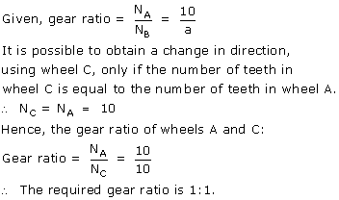

**MCQ.**

1. Greater than 1

Hint: 

**Exercise 3C.**

1. Fixed pulley: A pulley which has its axis of rotation fixed in position, is called a fixed pulley.

Single fixed pulley is used in lifting a small load like water bucket from the well.

1. The ideal mechanical advantage of a single fixed pulley is 1.

It cannot be used as force multiplier.

1. There is no gain in mechanical advantage in the case of a single fixed pulley. A single fixed pulley is used only to change the direction of the force applied that is with its use, the effort can be applied in a more convenient direction. To raise a load directly upwards is difficult.
2. The velocity ratio of a single fixed pulley is 1.
3. The load rises upwards with the same distance x.
4. Single movable pulley: A pulley, whose axis of rotation is not fixed in position, is called a single movable pulley.

Mechanical advantage in the ideal case is 2.

1. ?
2. The efficiency of a single movable pulley system is not 100% this is because

(i)The friction of the pulley bearing is not zero ,

(ii)The weight of the pulley and string is not zero.

1. The force should be in upward direction.

The direction of force applied can be changed without altering its mechanical advantage by using a single movable pulley along with a single fixed pulley to change the direction of applied force.

Diagram:

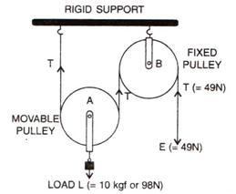

1. The velocity ratio of a single movable pulley is always 2.
2. The load is raised to a height of x/2.
3. Diagram:

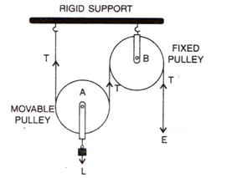

Ideal mechanical advantage of this system is 2. This can be achieved by assuming that string and the pulley are massless and there is no friction in the pulley bearings or at the axle or between the string and surface of the rim of the pulley.

1. (a)



(b)The fixed pulley B is used to change the direction of effort to be applied from upward to downward.

(c)The effort E balances the tension T at the free end, so E=T

(d)The velocity ratio of this arrangement is 2.

(e)The mechanical advantage is 2 for this system (if efficiency is 100%).



|  |  |
| --- | --- |
| Single fixed pulley | Single movable pulley |
| 1. It is fixed to a rigid support. | 1. It is not fixed to a rigid support. |
| 2. Its mechanical advantage is one. | 2. Its mechanical advantage is two. |
| 3. Its velocity ratio is one. | 3. Its velocity ratio is two. |
| 4. The weight of pulley itself does not affect its mechanical advantage. | 4. The weight of pulley itself reduces its mechanical advantage. |
| 5. It is used to change the direction of effort | 5. It is used as force multiplier. |

1. (a)Pulleys A and B are movable pulleys. Pulley C is fixed pulley.

(b)

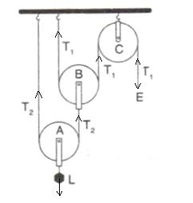

(c)The magnitude of effort E = T1

And the magnitude of L= 22T1 = 4 T1

(d)The mechanical advantage = 22 = 4

The velocity ratio = 22 = 4

(e)Assumption: the pulleys A and B are weightless.

1. Diagram:

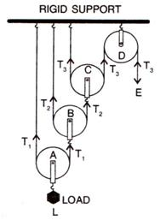

Tension T1 in the string passing over the pulley A is given as

2T1 = L or T1 = L/2

Tension T2 in the string passing over the pulley B is given as

2T2 = T1or T2 = T1/2 = L/22

Tension T3 in the string passing over the pulley C is given as

2T3 = T2orT3 = T2/2 = L/23

In equilibrium, T3 = E

E =L/23

Mechanical advantage = MA = L/E = 23

As one end of each string passing over a movable pulley is fixed, so the free end of string moves twice the distance moved by the movable pulley.

If load L moves up by a distance x, dL = x, effort moves by a distance 23x, dE = 23x

Velocity Ratio VR =http://cdn.topperlearning.com/topper/bookquestions/189372_image139.gif

Efficiency = MA/VR =23/ 23 = 1 or 100%



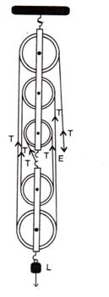

1. (a)In a single fixed pulley, some effort is wasted in overcoming friction between the strings and the grooves of the pulley; so the effort needed is greater than the load and hence the mechanical advantage is less than the velocity ratio.

(b)This is because of some effort is wasted in overcoming the friction between the strings and the grooves of the pulley.

(c)This is because mechanical advantage is equal to the total number of pulleys in both the blocks.

(d)The efficiency depends upon the mass of lower block; therefore efficiency is reduced due to the weight of the lower block of pulleys.

1. (a)Multiply force: a movable pulley.

(b)Multiply speed: gear system or class III lever.

(c)Change the direction of force applied: single fixed pulley.

1. (a)The velocity ratio of a single fixed pulley is always more than 1.(false)

(b)The velocity ratio of a single movable pulley is always 2.(true)

(c)The velocity ratio of a combination of n movable pulleys with a fixed pulley is always 2n.(true)

(d)The velocity ratio of a block and tackle system is always equal to the number of strands of the tackle supporting the load. (true)

**MCQ.**

1. It helps in applying effort in a convenient direction.

Explanation: A single fixed pulley though does not reduce the effort but helps in changing the direction of effort applied. As it is far easier to apply effort in downward direction, the single fixed pulley is widely used.

1. The mechanical advantage of an ideal single movable pulley is 2.

Derivation: Consider the diagram given below:

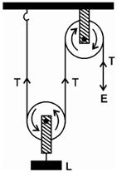

Here the load L is balance by the tension in two segments of the string and the effort E balances the tension T at the free end, so

L = T + T = 2T and E = T

Assumption: Weight of the pulley is negligible.

We know that,



Thus, a single movable pulley has a M.A. equal to 2.

1. Force multiplier

Explanation: The mechanical advantage of movable pulley is greater than 1. Thus, using a single movable pulley, the load can be lifted by applying an effort equal to half the load (in ideal situation), i.e. the single movable pulley acts as a force multiplier.