Class – IX CBSE (NCERT)
Chapter-8 Motion.
Page-100.
- Yes. An object that has moved through a distance can have zero displacement. Displacement is the shortest distance between the initial and the final position of an object. An object which has covered a distance can have zero displacement if it comes back to its starting point i.e., the initial position.
Consider the following situation. A man is walking along the boundary of a square park of side 20 m (as shown in the following figure). He starts walking from point A and after moving along all the sides of the park (AB, BC, CD, DA), he again comes back to the same point i.e., A.

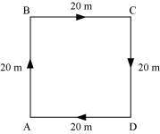

In this case, the total distance covered by the man is 20 m + 20 m + 20 m + 20 m = 80 m. However, his displacement is zero because the shortest distance between his initial and final position is zero.

Concept Insight - Distance and displacement may or may not be the same. Displacement is always less than or equal to the distance covered.

- The farmer takes 40 s to cover 4 × 10 = 40 m.
In 2 min and 20 s (140 s), he will cover a distance = 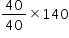 = 140 m
Therefore, the farmer completes 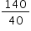=3.5 rounds (3 complete rounds and a half round) of the field in 2 min and 20 s.
That means, after 2 min 20 s, the farmer will be at the opposite end of the starting point.
Now, there can be two extreme cases.
Case I: Starting point is a corner point of the field.
In this case, the farmer will be at the diagonally opposite corner of the field after 2 min 20 s.
Therefore, the displacement will be equal to the diagonal of the field.
Hence, the displacement will be 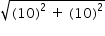 = 14.14 m
Case II: Starting point is the middle point of any side of the field.
In this case the farmer will be at the middle point of the opposite side of the field after 2 min 20 s.
Therefore, the displacement will be equal to the side of the field, i.e., 10 m.
For any other starting point, the displacement will be between 14.1 m and 10 m.
Concept Insight: - Be careful about considering the cases, as the displacement in both the cases is different.

- (a) Not true
Displacement can become zero when the initial and final positions of the object are the same.

(b) Not true

Displacement is the shortest distance between the initial and final positions of an object. It cannot be greater than the magnitude of the distance travelled by an object. However, sometimes, it may be equal to the distance travelled by the object.
Concept Insight - Displacement is always less than or equal to the distance covered.

Page-102.

Speed | Velocity
Speed is the distance travelled by an object per unit time. It does not have any direction. | Velocity is the displacement of an object per unit time. It has a unique direction.
Speed is a scalar quantity. | Velocity is a vector quantity.
The speed of an object can never be negative. At the most, it can become zero. This is because distance travelled can never be negative. | The velocity of an object can be negative, positive, or equal to zero. This is because displacement can take any of these three values.

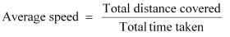

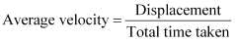

If the total distance covered by an object is the same as its displacement, then its average speed would be equal to its average velocity, i.e. when the object moves along a straight line path.
Concept Insight - Distance and displacement may or may not be equal to each other.

- The odometer of an automobile measures the distance covered by an automobile.

- An object having uniform motion has a straight line path.

- Time taken by the signal to reach the ground station from the spaceship
= 5 min = 5 × 60 = 300 s
Concept Insight - Convert all the quantities in the same units and then proceed to calculations.

Speed of the signal = 3 × 10⁸ m/s

Distance travelled = Speed × Time taken = 3 × 10⁸ × 300 = 9 × 10¹⁰ m

Hence, the distance of the spaceship from the ground station is 9 × 10¹⁰ m.

Page-103.
- (i) A body is said to have uniform acceleration if it travels in a straight path in such a way that its velocity changes at a uniform rate, i.e., the velocity of the body increases or decreases by equal amounts in an equal intervals of time. The motion of a freely falling body is an example of uniform acceleration.
(ii) A body is said to have non-uniform acceleration if its velocity changes at a non-uniform rate, i.e., the velocity of the body increases or decreases by unequal amounts in an equal intervals of time. The motion of a car on a crowded city road is an example of non-uniform acceleration.

Concept Insight - Acceleration is a vector quantity as it measured as the change in another vector quantity, i.e. velocity.

- Initial speed of the bus, u = 80 km/h 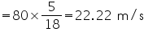
Final speed of the bus, v = 60 km/h 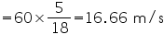
Time taken to decrease the speed, t = 5 s

Concept Insight - Convert all the quantities in the same units and then proceed to calculation part.
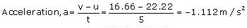
Here, the negative sign of acceleration indicates that the velocity of the car is decreasing.

- Initial velocity of the train, u = 0 (since the train is initially at rest)

Final velocity of the train, v = 40 km/h =
Time taken, t = 10 min =
Concept Insight - Convert all the quantities in the same units and then proceed to calculation part.

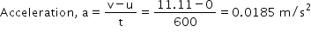
Hence, the acceleration of the train is 0.0185 m/s².

Page-107.
- The distance-time graph for uniform motion of an object is a straight line (as shown in the following figure).
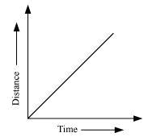
The distance-time graph for non-uniform motion of an object is a curved line (as shown in the given figure).

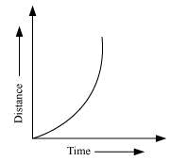

- When an object is at rest, its distance-time graph is a straight line parallel to the time axis.
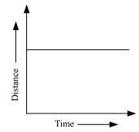

A straight line parallel to the x-axis in a distance-time graph indicates that with a change in time, there is no change in the position of the object. Thus, the object is at rest.

- Object is moving uniformly.

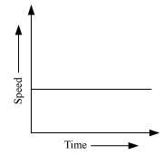

A straight line parallel to the time axis in a speed-time graph indicates that with a change in time, there is no change in the speed of the object. This indicates the uniform motion of the object.

- Distance
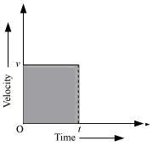

The graph shows the velocity-time graph of a uniformly moving body.
Let the velocity of the body at time (t) be v.
Area of the shaded region = length × breath
where,
Length = t
Breath = v
Area = vt = velocity × time ...(i)
We know,
Distance = Velocity x Time ...(ii)
From equations (i) and (ii),
Area = Distance
Hence, the area occupied below the velocity-time graph measures the distance covered by the body.

Page-109.
- (a) Initial speed of the bus, u = 0 (since the bus is initially at rest)

Acceleration, a = 0.1 m/s²

Time taken, t = 2 minutes = 120 s

Let v be the final speed acquired by the bus.

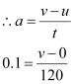

v = 12 m/s

(b) Concept Insight -First look at the quantities 'given' in the question and then the quantity need to be calculated. Further wisely choose the equation of motion out of the three, to minimize the calculations.

According to the third equation of motion:
v² - u² = 2as
where, s is the distance covered by the bus
(12)² - (0)² = 2(0.1) s
s = 720 m
So, speed acquired by the bus is 12 m/s.
Distance travelled by the bus is 720 m.

Page-110.
- Initial speed of the train, u = 90 km/h = 25 m/s

Final speed of the train, v = 0 (finally the train comes to rest)

Acceleration = -0.5 m s⁻²
According to third equation of motion:

v ² = u ² + 2as

Concept Insight - Wisely choose the equation of motion out of the three, to minimize the
calculations.

(0)² = (25)² + 2 (-0.5) s

where, s is the distance covered by the train

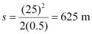

The train will cover a distance of 625 m before it comes to rest.

- Initial velocity of the trolley, u = 0 (since the trolley was initially at rest)
Acceleration, a = 2 cm s⁻² = 0.02 m/s²
Time, t = 3s
According to the first equation of motion:
v = u + at
Concept Insight - Choose the equation of motion wisely out of the three, to minimize the number of steps in calculations.
where, v is the velocity of the trolley after 3s from start
v = 0 + 0.02 × 3 = 0.06 m/s
Hence, the velocity of the trolley after 3s from start is 0.06 m/s.

- Initial velocity of the racing car, u = 0 (since the racing car is initially at rest)
Acceleration, a = 4 m/s²
Time taken, t = 10 s
According to the second equation of motion:
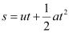
Concept Insight - Choose the equation of motion wisely out of the three, to minimize the number of steps in calculations.
where, s is the distance covered by the racing car
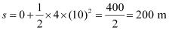

Hence, the distance covered by the racing car after 10 s from start is 200 m.

- Initially, velocity of the stone, u = 5 m/s
Final velocity, v = 0 (since the stone comes to rest when it reaches its maximum height)
Acceleration of the stone, a = acceleration due to gravity, g = 10 m/s² (in downward direction)
There will be a change in the sign of acceleration because the stone is being thrown upwards.
Concept Insight - Change in sign of the acceleration due to change in direction is crucial as it'll change the results.
Acceleration, a = -10 m/s²
Let s be the maximum height attained by the stone in time t.
According to the first equation of motion:
v = u + at
0 = 5 + (-10) t
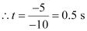
According to the third equation of motion:
v ² = u ² + 2 as
(0) ² = (5) ² + 2(-10) s
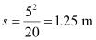
Hence, the stone attains a height of 1.25 m in 0.5 s.
Page-112.
- Diameter of the circular track, d = 200 m
Radius of the track, 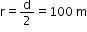
Circumference = 2r = 2(100) = 200 m
Concept Insight - Circumference of a circle is given by (2 × × r) where, r is the radius of the circle and = 22/7.
In 40 s, the given athlete covers a distance of 200 m.
In 1 s, the given athlete covers a distance = 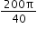m
The athlete runs for 2 minutes 20 s = 140 s

Total distance covered in 140 s = 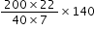=2200 m
The athlete covers one round of the circular track in 40 s. This means that after every 40 s, the athlete comes back to his original position. Hence, in 140 s he had completed 3 rounds of the circular track and is taking the fourth round.
He takes 3 rounds in 40 × 3 = 120 s. Thus, after 120s his displacement is zero.
Then, the net displacement of the athlete is in 20 s only. In this interval of time, he moves at the opposite end of the initial position. Since displacement is equal to the shortest distance between the initial and final position of the athlete, displacement of the athlete will be equal to the diameter of the circular track.
Displacement of the athlete = 200 m
Distance covered by the athlete in 2 min 20 s is 2200 m and his displacement is 200 m.

- (a) From end A to end B

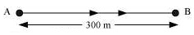

Distance covered by Joseph while jogging from A to B = 300 m

Time taken to cover that distance = 2 min 30 seconds = 150 s

Total distance covered = 300 m

Total time taken = 150 s

Average speed = 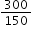= 2 m/s

Displacement = Shortest distance between A and B = 300 m

Time interval = 150 s
Average velocity = 300/150 = 2 m/s

The average speed and average velocity of Joseph from A to B are the same and equal to 2 m/s.

(b) From end A to end C
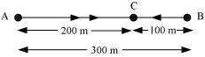

Total distance covered = Distance from A to B + Distance from B to C = 300 + 100 = 400 m

Total time taken = Time taken to travel from A to B + Time taken to travel from B to C = 150+ 60 = 210 s
Average speed = 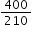 = 1.90 m/s

Displacement from A to C = AC = AB - BC = 300 - 100 = 200 m

Time interval = Time taken to travel from A to B + Time taken to travel from B to C = 150 + 60 = 210 s
Average velocity = 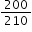= 0.95 m/s

The average speed of Joseph from A to C is 1.90 m/s and his average velocity is 0.95 m/s.

Concept Insight - Average speed and average velocity may or may not be same all the time.

- Case I: While driving to school

Average speed of Abdul's trip = 20 km/h

Total distance = Distance travelled to reach school = d

Let total time taken = t₁
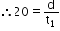
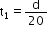 .... (i)

Case II: While returning from school

Total distance = Distance travelled while returning from school = d

Now, total time taken = t₂

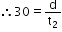
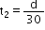 .... (ii)

where,

Total distance covered in the trip = d + d = 2 d

Total time taken, t = Time taken to go to school + Time taken to return to school = t₁ + t₂

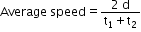

Concept Insight - Consider the two cases individually to make the calculations clear and easy.
From equations (i) and (ii),

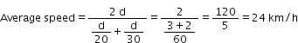

Hence, the average speed for Abdul's trip is 24 km/h.

- Initial velocity, u = 0 (since the motor boat is initially at rest)
Acceleration of the motorboat, a = 3 m/s²

Time taken, t = 8 s

According to the second equation of motion:

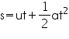
Concept Insight - Choose the equation of motion wisely out of the three, to minimize the number of steps in calculations.
Distance covered by the motorboat, s

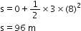

Hence, the boat travels a distance of 96 m.

- For first car:
Initial speed of the car, u₁ = 52 km/h = 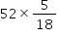 = 14.4 m/s
Time taken to stop the car, t₁ = 5 s
Final speed of the car becomes zero after 5s of application of brakes.
For second car:
Initial speed of the car, u₂ = 3 km/h = 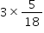 = 0.83 m/s
Time taken to stop the car, t₂ = 10 s
Final speed of the car becomes zero after 10 s of application of brakes.
Plot of the speed versus time graph for the two cars is shown in the following figure:
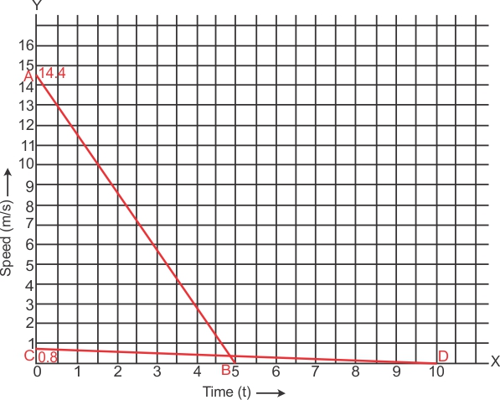
Concept Insight - Distance covered by each car is equal to the area under the speed-time graph.
Distance covered by first car = Area under the graph line AB
= Area of triangle OAB
= 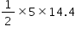 = 36 m
Distance covered by second car = Area under the graph line CD
= Area of triangle OCD
= 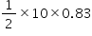 = 4.15 m
Area of triangle OAB > Area of triangle OCD
Thus, the distance covered by first car is greater than the distance covered by second car.
Hence, the car travelling with a speed of 52 km/h travelled farther after brakes were applied.

- (a) Object B
(b) No
(c) 5.714 km
(d) 5.143 km

(a) Slope of the distance-time graph of an object indicates its speed. Greater the slope, greater is the speed. Among the given graphs, the slope of distance-time graph of object B is the maximum, so object B is travelling the fastest.

(b) The distance-time graphs of the three objects A, B and C never meet at a single point. Thus, they are never at the same point on the road.

(c)
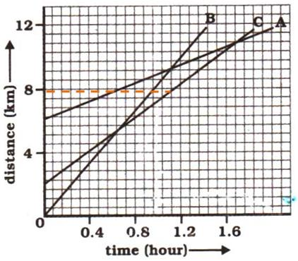

On the distance axis:

7 small boxes = 4 km

1 small box = 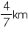
Initially, object C is 4 blocks away from the origin.

Initial distance of object C from origin= 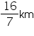
Concept Insight - Final reading will be initial distance already covered minus the total distance covered.

Distance of object C from origin when B passes A = 8 km

Distance covered by C 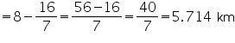
Hence, C has travelled a distance of 5.714 km when B passes A.

(d)
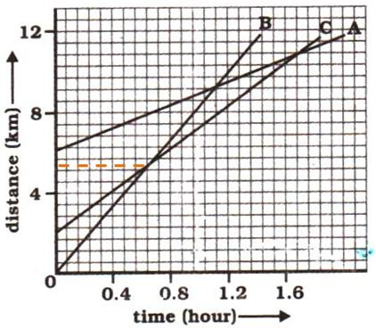

Distance covered by B at the time it passes C = 9 boxes

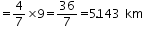
Hence, B has travelled a distance of 5.143 km when it passes C.

Page-113.
- Distance covered by the ball, s = 20 m
Acceleration, a = 10 m/s²
Initial velocity, u = 0 (since the ball was initially at rest)
Final velocity of the ball with which it strikes the ground, v
According to the third equation of motion:
v ² = u ² + 2 as
v ² = 0 + 2 (10) (20)
v = 20 m/s
Concept Insight - Choose the equation of motion wisely out of the three, to minimize the number of steps in calculations.

The ball will strike the ground with a velocity 20 m/s.
According to the first equation of motion:
v = u + at
20 = 0 + 10 (t)
t = 2s
Hence, the ball will strike the ground after 2s with a velocity of 20 m/s.

- (a) The distance travelled by the car in the first 4 seconds is given by the area between the curve and the time axis from t = 0 to t = 4 s. This area has been shaded in the graph below.
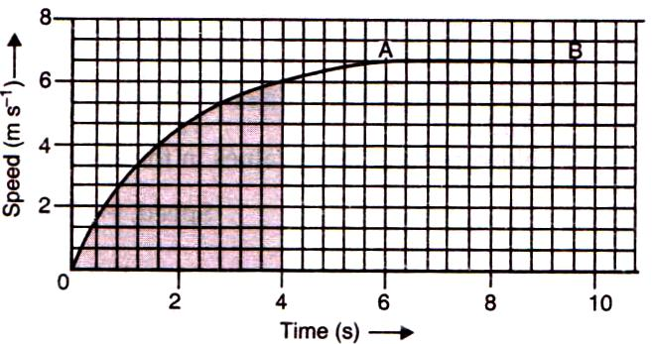
Number of squares in the shaded part of the graph = 62
Concept Insight: While counting the number of squares in the shaded part of the graph, the squares which are half or more than half are counted as complete squares but the squares which are less than half are not counted.
On X-axis,
5 squares represent 2 s.
1 square represents s.
On Y-axis,
3 squares represent 2 m/s.
1 square represents m/s.
So, area of 1 square on the graph = 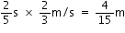
Area of the shaded region of the graph = 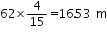
Therefore, the car travels a distance of 16.53 m in the first 4 seconds.

(b) The uniform motion of the car is represented by the part AB of the graph, which represents constant speed.

- (a) Possible

When a ball is just released from a height, then it is being acted upon by a constant acceleration equal to the acceleration due to gravity i.e. 9.8 m/s² but its initial velocity is zero.

Concept Insight - An object with a constant acceleration but with zero velocity is possible.

(b) Possible
When a car is moving in a circular track, its acceleration is perpendicular to its direction of motion at each instant.

Concept Insight - An object moving in a certain direction with an acceleration in the perpendicular direction is also possible.

- Concept Insight - Circumference of a circle is given by (2 x x r) where, r is the radius of the circle and = 22/7 = 3.14

Radius of the circular orbit, r = 42250 km

Time taken to revolve around the Earth, t = 24 h
Speed of an object moving in a circular orbit, 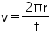
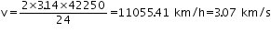
Hence, the speed of the artificial satellite is 3.07 km/s

